**A College Student's Reinforcement Learning Exploration**

**-Phani Bharadwaj Jarugumilli**

Greetings, fellow learners! Welcome to my exploration of Reinforcement Learning (RL), an enthralling journey that began in my sophomore year of college. Pursuing a major in Computer Science, I found myself drawn to the captivating world of RL through the intriguing Pong from Pixels project.

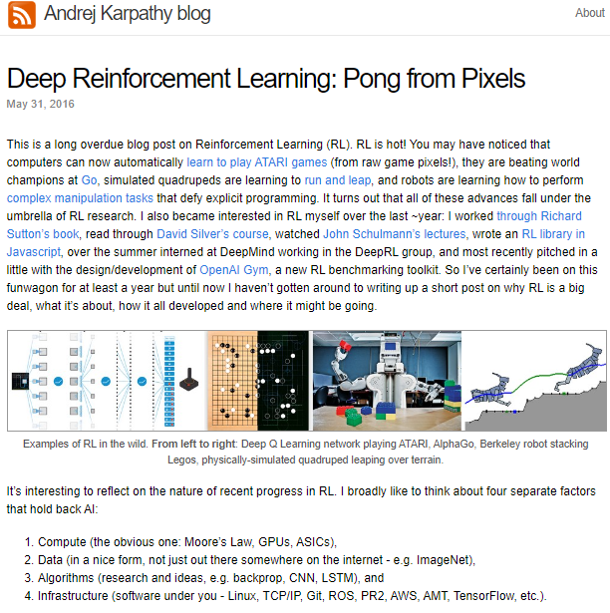As we venture together into the depths of this transformative technology, I aim to share not just the technical intricacies but also the excitement and challenges of grasping RL concepts.

**Project Overview and Goals**

**Introduction to SmartPong Project:**

As we set sail into the intricate waters of Reinforcement Learning (RL), our vessel is the SmartPong project. This undertaking involves recreating the classic arcade game, Pong, from scratch. Through this hands-on experience, we will unravel the intricacies of game development, machine learning, and specifically, RL.

**Learning Through Game Development:**

The foundation of our journey lies in the recreation of Pong. This entails manipulating pixels, understanding game mechanics, and crafting engaging gameplay. While challenging at the outset, this phase promises a rich and rewarding learning experience for both novice and seasoned learners.

**Exploring Reinforcement Learning:**

SmartPong serves as our playground for delving into RL concepts. Through practical experimentation, we will observe how our game AI evolves through trial and error, akin to teaching a virtual brain the art of playing Pong. This immersive approach ensures a deep understanding of RL principles as we witness our AI player adapt and enhance its gameplay.

**Objectives and Milestones:**

Our primary objective is clear: guide you through the construction of SmartPong. By the journey's end, you will witness your own AI player autonomously engaging in Pong matches, challenging other AI opponents or even the computer. To achieve this, we will conquer several milestones:

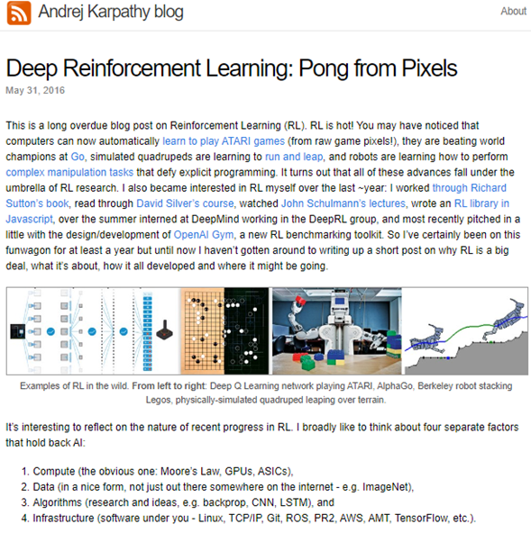

1. **Preprocessing Pixel Data:**

* Transforming raw visual information into a format suitable for our AI agent to learn and make decisions. Think of it as teaching our AI to "see" and understand the game environment.

1. **Designing Neural Networks:**

* Constructing the neural network architecture that powers our AI player, enabling it to process information and devise strategies.

1. **Implementing Reinforcement Learning Algorithms:**

* Delving into the world of RL, teaching our AI player to learn from its mistakes and improve its gameplay over time.

1. **Fine-tuning for Peak Performance:**

* Optimizing various parameters to ensure our AI player performs at its best, tweaking its performance for superior gameplay.

1. **Tracking the Progress:**

* To understand how tweaking each parameter affects the model performance, it is vital that we track our Progress (preferably using a pictorial representation like a graph)

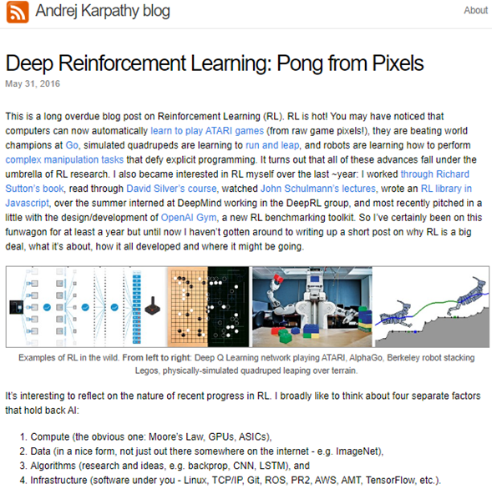**Enduring Benefits of the Project:**

The SmartPong project extends beyond the immediate goal of creating an AI player. Participants can expect to gain:

**Deeper Understanding of RL:**

* A hands-on exploration that imparts a profound understanding of RL principles.

**Practical Experience with Coding Libraries:**

* Working with modern libraries and software, enhancing coding skills and preparing for future endeavors in game development and machine learning.

**Preparation for Advanced Topics:**

* Prepare for advanced topics in RL, laying the groundwork for further exploration in machine learning and artificial intelligence.

**Creative Expression:**

* Unleash creativity in programming and design, exploring innovative ways to enhance your AI player's capabilities.

**Algorithmic Understanding:**

* Gain a profound understanding of RL algorithms, providing a solid foundation for future endeavors in AI research.

**Versatile Application of RL Concepts:**

* Apply RL concepts learned in SmartPong to diverse real-world scenarios, from robotics to autonomous systems.

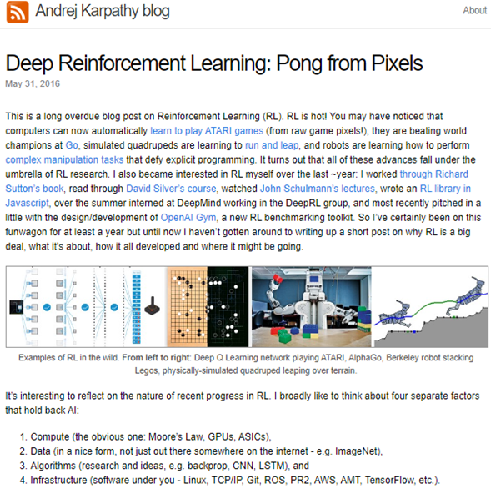**Prompt:**

**Hey GPT, so I need your help to explain a blog written by Andrej Karpathy called Pong from Pixels. In his blog he goes into his exploration about Reinforcement Learning and what he learnt, how he trained his model using Reinforcement Learning to make it play and win pong against the engine. Now I have full access to the blog. So, what we are going to be doing is, I will be pasting the content from the blog 1 page at a time. And the main goal is to rewrite the blog as Karpathy has high end language in his blog. I need your help to rewrite it such that , I present it as my blog (college student's perspective) and each page that I paste, the explanation you generate should be understandable by high school teachers with zero knowledge of AI.**

**Title : Discovering Deep Reinforcement Learning: A Peek into the World of AI**

Welcome, curious minds, to the intriguing realm of Deep Reinforcement Learning (RL)! In this exploration, we will unravel the magic of RL in a way that everyone can understand.

Imagine RL as a superpower for computers, allowing them to learn and achieve incredible feats. Picture this – computers playing video games like ATARI, mastering strategic games like Go, mimicking how animals move, and guiding robots through complex tasks without anyone giving them a step-by-step guide. These remarkable capabilities are all part of the exciting world of RL.

Now, let us dive deeper into Andrej's blog, where he reflects on the recent progress in RL. He likes to think about four factors that hold back AI, and it is quite interesting:

1. **Compute:**
   * This is like the engine of AI. It is what makes computers powerful and fast. It is driven by things like Moore's Law (which means computers get faster over time), Graphics Processing Units (GPUs - imagine them as the muscle for processing visuals), and Application-Specific Integrated Circuits (ASICs - specialized chips designed for certain tasks). Think of it as upgrading a car's engine to make it faster and more efficient.



1. **Data:**
   * Imagine data as the fuel for AI. It's not just about having data out there on the internet; it's about having organized and useful data. For example, ImageNet is a collection of organized images that computers can learn from effectively.
2. **Algorithms:**

These are like the brains of AI. Let's break down the terms:

* + **Backpropagation:** Think of it as the way AI corrects itself. When it makes a mistake, backpropagation helps it understand and learn from the error.
  + **Convolutional Neural Networks (CNNs):** Imagine this as the specialized part of AI that's excellent at understanding images. It's like the visual cortex in our brains but for computers.
  + **Long Short-Term Memory networks (LSTMs):** Picture this as the memory of AI. It helps AI remember things for a more extended period, making it better at learning from sequences of data.
  + Research and ideas, such as backpropagation, Convolutional Neural Networks (CNNs), and Long Short-Term Memory networks (LSTMs), are the building blocks that make AI intelligent.

1. **Infrastructure:**

* Now, let's talk about the backstage crew, the tech backbone supporting AI:
* **Operating System (OS):** Like your computer's brain, managing tasks and keeping things organized for AI.
* **Communication Protocol (TCP/IP):** It's the language computers use to talk to each other, ensuring effective information exchange.
* **Version Control System (Git):** Think of it as an organized file system, helping AI track changes and fix mistakes easily.
* **Robot Operating System (ROS):** It's the choreographer for robots, providing instructions for efficient task performance.
* **Cloud Platforms (e.g., AWS):** Like renting virtual space, platforms such as AWS offer AI a place to crunch numbers and learn on the internet.

In Andrej's own words on his blog, he shares his personal journey into RL. Picture him diving into books, exploring courses, and even interning at a fascinating place called DeepMind. Working alongside a group of experts, he played a part in crafting tools for RL experiments.

Despite being on this thrilling journey for over a year, he hasn't had the chance to simplify his experiences until now. That's what makes this blog post special – it's about breaking down why RL is such a big deal, how it operates, and where it might head in the future.

Throughout Andrej's learning adventure, he didn't just read about RL; he got his hands dirty. He used different resources and had practical experiences, adding his touch to both the theory and the real-world applications of RL.

**Step by step Installation setup guidelines:**

An **Integrated Development Environment (IDE)** is a software application that provides comprehensive facilities for software development. It typically includes a code editor, compiler, or interpreter, build automation tools, and debugging functionality, all integrated into a single user interface. IDEs are designed to streamline the development process by providing developers with everything they need to write, test, and debug code within a unified environment.

Here's why you will need an IDE for implementing the AI Pong project:

1. **Code Editing:** IDEs offer advanced code editing features such as syntax highlighting, code completion, and code refactoring, which help improve productivity and reduce errors while writing code for your AI Pong project.
2. **Debugging:** IDEs come with built-in debugging tools that allow you to set breakpoints, inspect variables, and step through your code line by line to identify and fix issues. This is essential for troubleshooting errors and optimizing the performance of your AI Pong implementation.
3. **Project Management:** IDEs provide project management features that help you organize your code files, manage dependencies, and navigate between different components of your AI Pong project more efficiently.
4. **Version Control Integration:** Many IDEs offer integration with version control systems like Git, allowing you to track changes to your code, collaborate with other developers, and manage code revisions effectively.
5. **Code Analysis and Refactoring:** IDEs often include tools for static code analysis and refactoring, which can help you identify potential code smells, improve code quality, and optimize the structure of your AI Pong implementation.
6. **Plugin Ecosystem:** IDEs typically support a wide range of plugins and extensions that extend their functionality and cater to specific development needs. You can leverage these plugins to enhance your workflow and integrate additional tools and services into your AI Pong project.

Overall, using an IDE for implementing the AI Pong project can significantly improve your development experience, increase productivity, and facilitate the creation of a robust and efficient solution.

here are some popular IDEs that can be used for implementing the AI Pong project, along with brief descriptions and installation guidelines:

1. **PyCharm**:
   * 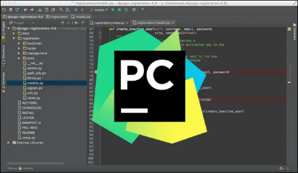Description: PyCharm is a powerful Python IDE developed by JetBrains. It provides intelligent code assistance, code navigation, and debugging capabilities, making it suitable for both beginners and experienced developers.
   * Installation:
     + Download the PyCharm Community Edition from the JetBrains website.
     + Follow the installation instructions provided for your operating system (Windows, macOS, or Linux).
     + Once installed, open PyCharm and create a new Python project for your AI Pong implementation.
     + You can install additional Python packages and libraries using PyCharm's built-in package manager.
2. **Visual Studio Code (VS Code)**:
   * Description: VS Code is a lightweight and versatile code editor developed by Microsoft. It offers a wide range of extensions and customization options, making it popular among Python developers.
   * Installation:
     + Download the installer for [VS Code from the official website](https://code.visualstudio.com/).
     + Run the installer and follow the on-screen instructions to complete the installation.
     + Open VS Code and install the Python extension from the Visual Studio Code Marketplace.
     + Create a new folder for your AI Pong project and open it in VS Code.
     + You can write Python code, manage dependencies, and run your project directly from VS Code.
3. **Jupyter Notebook**:
   * Description: Jupyter Notebook is an open-source web application that allows you to create and share documents containing live code, equations, visualizations, and narrative text. It's ideal for prototyping and experimenting with machine learning algorithms like Policy Gradients.
   * Installation:
     + Install Jupyter Notebook using pip by running the command **pip install notebook** in your terminal or command prompt.
     + Once installed, launch the Jupyter Notebook server by running the command **Jupyter notebook**.
     + This will open a new tab in your web browser with the Jupyter Notebook interface.
     + Create a new Python notebook and start writing and executing code cells for your AI Pong project.
     + You can install additional Python packages and libraries within the notebook using the **!pip install** command.

These IDEs provide different features and workflows, so you can choose the one that best suits your preferences and development needs for implementing the AI Pong project.

**I will be using Visual Studio Code (VS Code)** for this project and here is why it is a fantastic choice for your AI Pong project: It's a lightweight yet powerful code editor with excellent support for Python development. With its intuitive interface and extensive feature set, you'll find it easy and efficient to write, debug, and run your Python code.

Here's why VS Code is a great fit for your project:

1. **Ease of Use**: VS Code provides a user-friendly interface that makes it easy to navigate your project files, write code, and manage extensions.
2. **Python Integration**: With the Python extension installed, VS Code offers rich features for Python development, including code completion, syntax highlighting, linting, debugging, and more.
3. **Debugging Tools**: VS Code's built-in debugging tools allow you to set breakpoints, step through your code, and inspect variables, making it easier to identify and fix issues in your AI Pong implementation.
4. 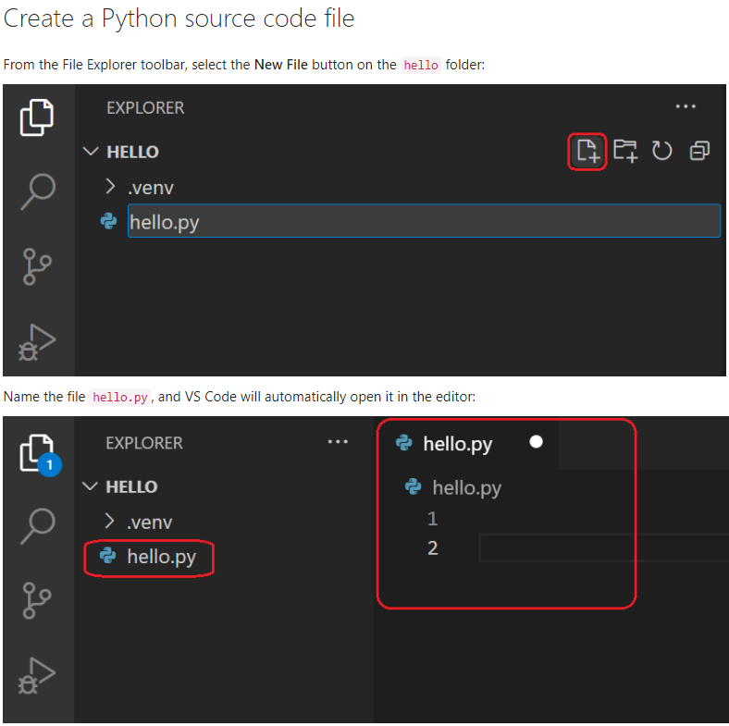**Customizability**: VS Code is highly customizable, allowing you to tailor the editor to your preferences with themes, key bindings, and extensions.
5. **Cross-Platform Support**: Whether you're using Windows, macOS, or Linux, VS Code provides a consistent development experience across different operating systems.

By using Visual Studio Code for your AI Pong project, you'll have a reliable and efficient environment for writing and testing your code. Since I will be using VS code, here is the step by step guidelines for setting up VS code in your computer.

**Installation:**

1. **Download VS Code**: Visit the [official Visual Studio Code website](https://code.visualstudio.com/) and download the installer for your operating system (Windows, macOS, or Linux).
2. **Run the Installer**: Once the download is complete, run the installer file and follow the on-screen instructions to install VS Code on your computer.
3. 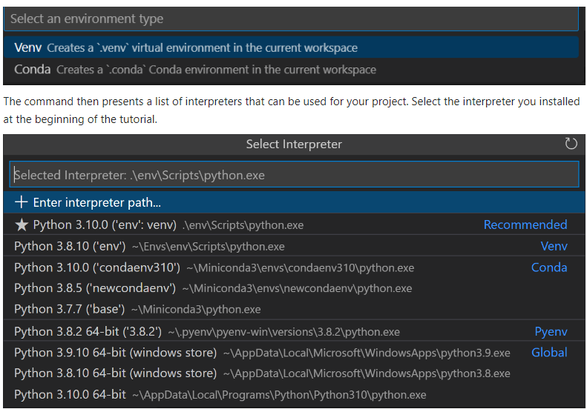**Open VS Code**: After the installation is complete, launch Visual Studio Code from your desktop or application menu.

**Writing and Running Code:**

1. **Create Python Files**: In VS Code, create a new Python file (e.g., **pong_ai.py**) and start writing your AI Pong code using the Python programming language.
2. **Debugging**: Use VS Code's built-in debugging features to set breakpoints, step through your code, and inspect variables during execution. You can debug Python scripts by clicking on the debug icon in the Sidebar or pressing **F5** and selecting the Python environment.
3. **Running Code**: You can run your Python scripts directly from VS Code by clicking the Run icon in the Sidebar or pressing **Ctrl+F5**. Output will be displayed in the integrated terminal.

Top of Form

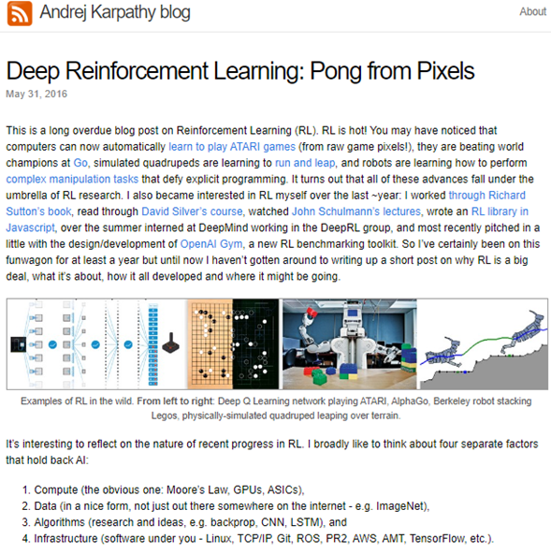

Python Installation

1. 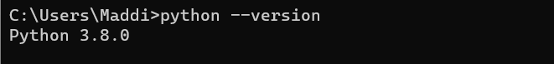Before proceeding with the installation, check if Python is already installed on your system and its version. You can do this by opening a command prompt (or terminal on macOS/Linux) and typing python --version. If Python is installed, it will display the version number. If not, you'll see a message indicating that Python is not recognized as a command.

So, in my case it’s already installed. If it’s not installed on your computer, go ahead and follow the below instructions.

1. Install **Python 3.8** from this website : <https://www.python.org/downloads/release/python-380/> and choose the Windows x86-64 executable installer option (for AMD64/EM64T/x64)

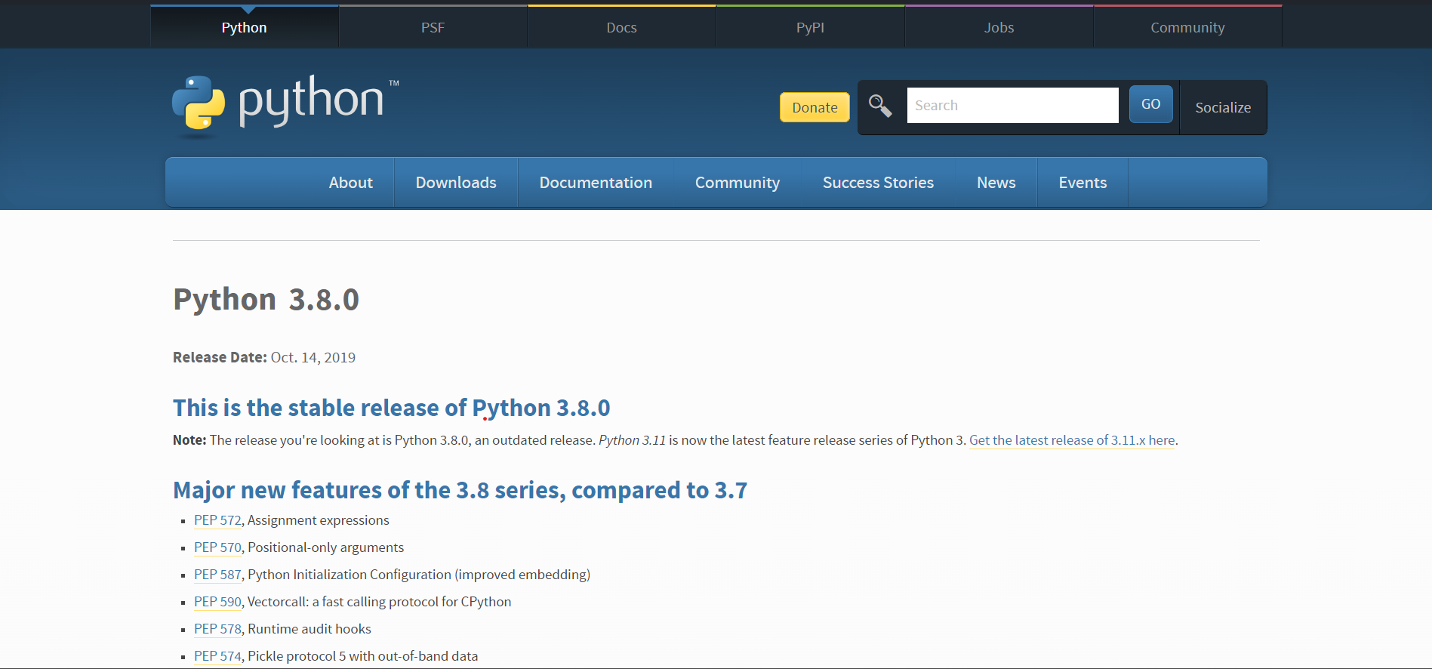

1. After successfully installing Python 3.8, open it in VS code <- (its icon looks like this) VS code is an integrated development environment (IDE) software.

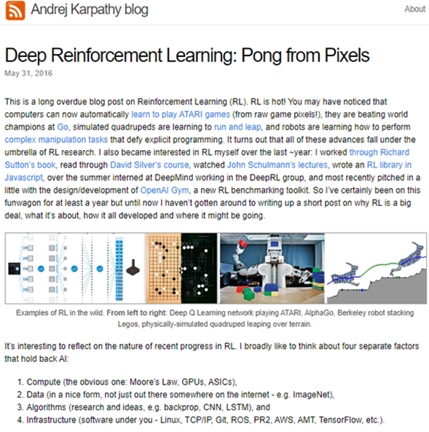**Setting up the Environment**

1. Now after the installation of Python 3.8.0, we are going to then write some commands in the command prompt to setup the environment for our Pong game to work properly in Python.
2. Look at the below picture to see how Python in VS code looks like. Once you have successfully created a Python file in VS code and saved it as per the name you desire (in my case I have saved it as Random.py), click on the Terminal button on the Taskbar on the top.
3. After pressing the Terminal button select New Terminal option in the menu that appears.

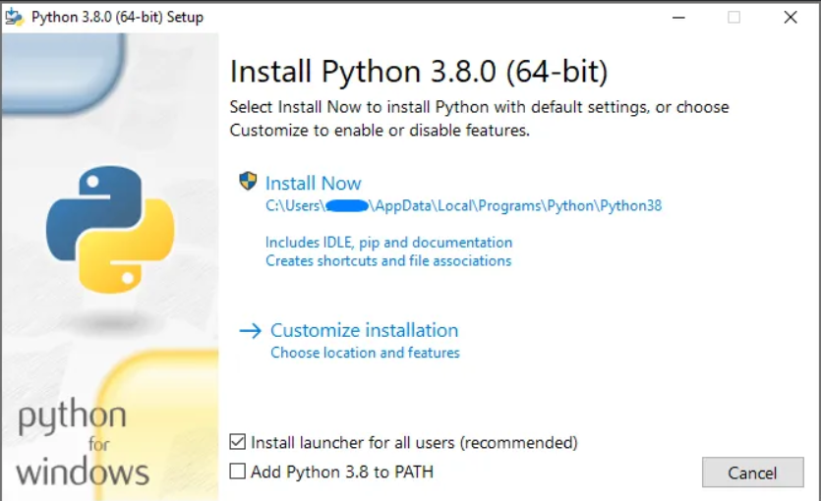

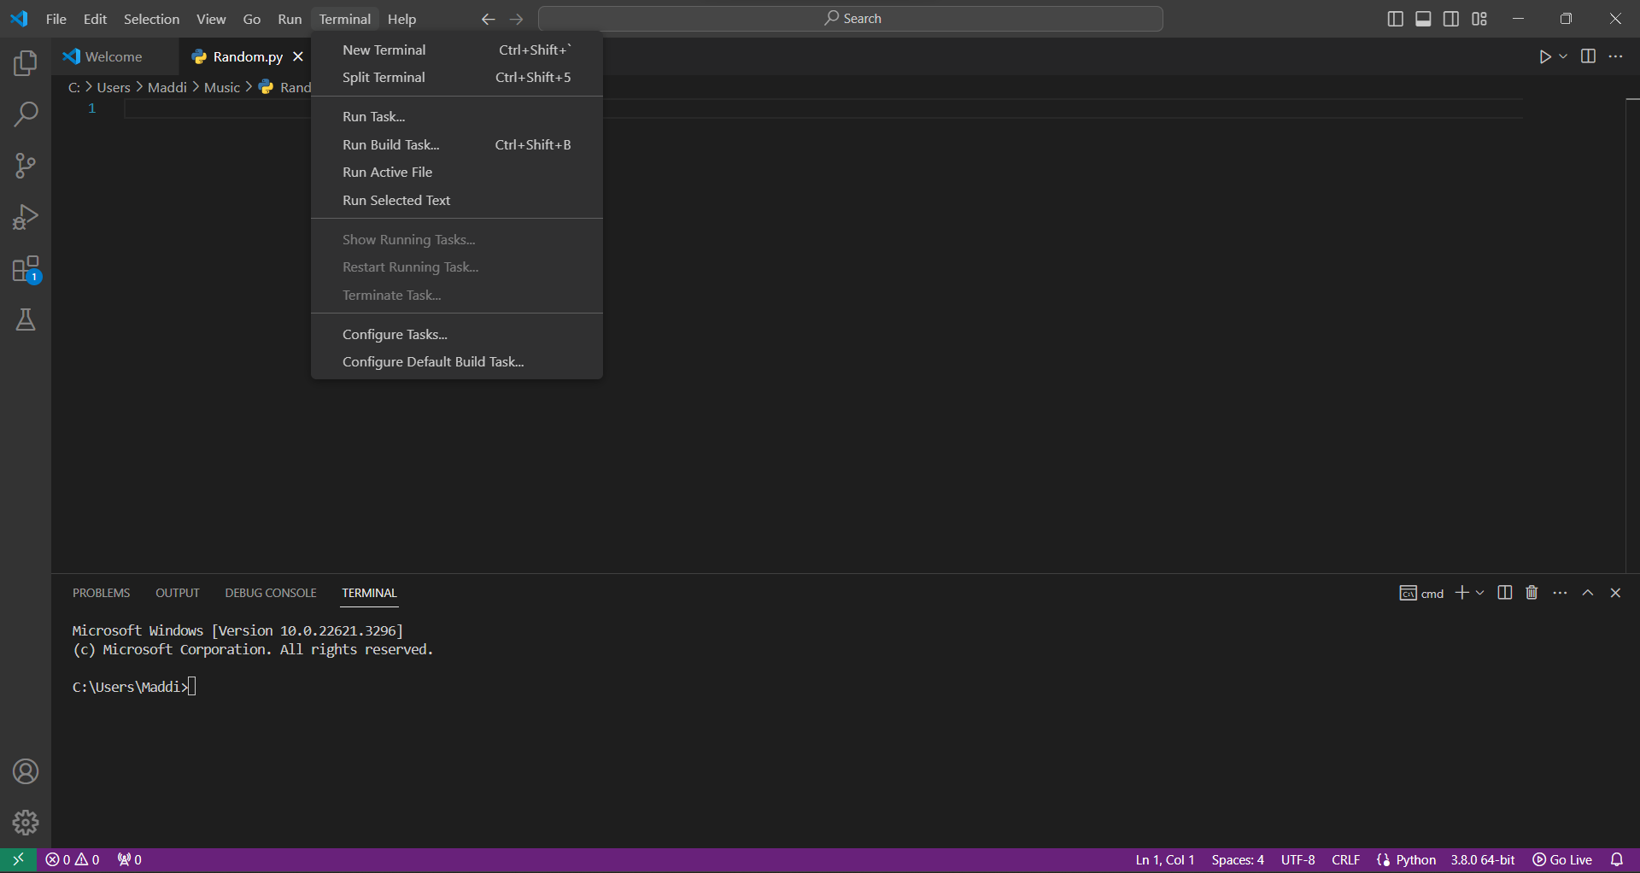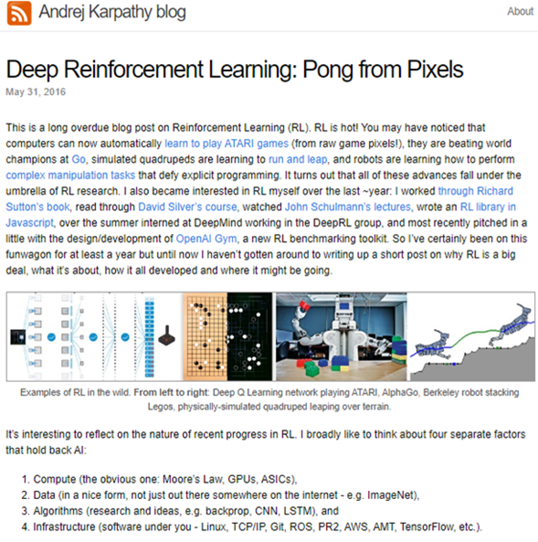

1. 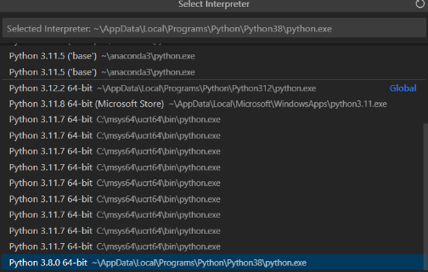Now you can see the Terminal window opened in the bottom part of the above picture. To verify that you have the Python 3.8.0 version as the selected interpreter press ctrl+shift+p. Upon pressing those keys, you will see a menu open with many options. Select the Python: Select Interpreter Option as you can see below in the picture.
2. The last line highlighted in blue shows that Python 3.8.0 64-bit is my current chosen interpreter for the File that I have created. If that is not the highlighted one in your case, then go ahead and select it.



1. After that we are supposed to pass in a few pip commands to the terminal so that all the dependencies (i.e. the files necessary to utilize the Pong environment in our file) are properly installed. While running the following pip commands it is important to keep in mind to not update the pip version that comes with the 3.8.0 Python interpreter version as the syntax that we are going to follow requires the older pip version for us to be able to install the dependencies without any errors using the following commands.

You may see the above message as you run the below commands. Don’t upgrade the pip as it will cause errors and syntax compatibility issues when you try and run the below commands to install the dependencies after updating the pip version.

* pip install gym
* pip install gym[atari,accept-rom-license]==0.21.0
* pip install numpy
* pip install matplotlib

After you have successfully installed the above dependencies the Environment setup is fully completed !

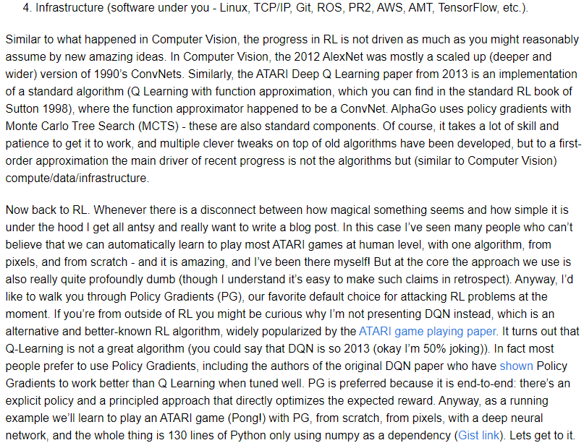**Prompt:**

**There are some terminologies that people with zero knowledge in AI may not be aware of. Generate an elaborated and simpler version**

**Title: Deciphering the Simplicity Behind Reinforcement Learning**

In Andrej's blog, he compares the progress in Reinforcement Learning (RL) to that in Computer Vision, emphasizing that major advancements often arise from simple concepts rather than entirely novel ideas.

He uses examples like the 2012 AlexNet in Computer Vision, which was essentially a larger version of Convolutional Neural Networks (ConvNets) from the 1990s. Similarly, the ATARI Deep Q Learning paper from 2013 implemented a standard RL algorithm called Q Learning with function approximation, using ConvNets for this purpose.

Even AlphaGo, the AI system that conquered world champions in the game of Go, utilized standard components such as policy gradients with Monte Carlo Tree Search (MCTS) in RL.

Let's break down some of the AI terminologies mentioned here for better understanding:

1. **Convolutional Neural Networks (ConvNets):** ConvNets are a type of artificial neural network commonly used in deep learning for analyzing visual imagery. They are designed to learn spatial hierarchies of features automatically and adaptively from input images. The term "convolutional" refers to the mathematical operation of convolution, which is used to extract features from the input images.
2. **AlexNet:** AlexNet is a deep convolutional neural network architecture that was introduced in 2012 by Alex Krizhevsky, Ilya Sutskever, and Geoffrey Hinton. It marked a significant breakthrough in computer vision by winning the ImageNet Large Scale Visual Recognition Challenge (ILSVRC) in 2012.

AlexNet was one of the first deep neural networks to demonstrate superior performance in image classification tasks.

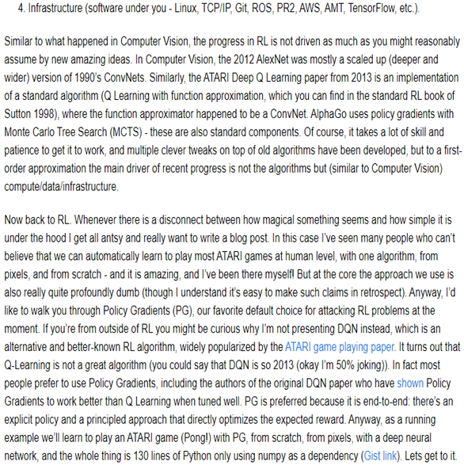

1. **ATARI Deep Q Learning:** This refers to a seminal paper published in 2013 by researchers at DeepMind, including Volodymyr Mnih, Koray Kavukcuoglu, David Silver, Andrei A. Rusu, Joel Veness, Marc G. Bellemare, Alex Graves, Martin Riedmiller, Andreas K. Fidjeland, Georg Ostrovski, Stig Petersen, Charles Beattie, Amir Sadik, Ioannis Antonoglou, Helen King, Dharshan Kumaran, Daan Wierstra, Shane Legg, and Demis Hassabis.

The paper introduced a deep reinforcement learning algorithm known as Deep Q-Networks (DQN), which achieved state-of-the-art performance in playing a variety of ATARI 2600 games directly from raw pixel inputs.

1. **Q Learning:** Q Learning is a fundamental reinforcement learning algorithm used for making decisions in uncertain environments. It learns optimal policy by iteratively estimating the value of taking a particular action in a given state and updating the action-value function (Q-function) accordingly.
2. **Function Approximation:** Function approximation refers to the process of approximating complex mathematical functions using simpler functions or models. In the context of Q Learning, function approximation techniques are used to estimate the value of state-action pairs, allowing the algorithm to generalize its knowledge to unseen states.
3. **AlphaGo:** AlphaGo is an AI program developed by DeepMind to play the board game Go. It made headlines in 2016 when it defeated Lee Sedol, one of the world's best Go players, in a five-game match. AlphaGo utilizes advanced reinforcement learning techniques, including policy gradients with Monte Carlo Tree Search (MCTS), to learn optimal strategies for playing Go.
4. **Policy Gradients (PG):** Policy Gradients is a class of reinforcement learning algorithms that directly learn the policy (strategy) of an agent by optimizing the expected cumulative reward. Unlike value-based methods like Q Learning, which estimate the value of actions, policy gradient methods learn a parameterized policy that maps states to actions.
5. **Monte Carlo Tree Search (MCTS):** MCTS is a heuristic search algorithm used in decision processes, particularly in game-playing AI. It builds a search tree by simulating sequences of actions from the current state and selecting actions based on the outcomes of these simulations. MCTS has been successfully applied in games like Go and Chess.

Despite the impressive achievements of RL systems, Andrej stresses that the underlying principles are often surprisingly simple. Many people find it hard to believe that AI can learn to play ATARI games at a human level using only one algorithm, from raw pixels, and starting from scratch.

However, he asserts that the fundamental approach in RL is quite straightforward, even if it doesn't seem that way initially. Nevertheless, Andrej is eager to illuminate the simplicity behind these remarkable accomplishments through his blog post.

Moving forward, Andrej introduces **Policy Gradients (PG)** as the preferred method for addressing RL challenges.

He explains why he focuses on PG instead of the more well-known Deep Q-Network (DQN) algorithm, which gained popularity after the ATARI game playing paper.

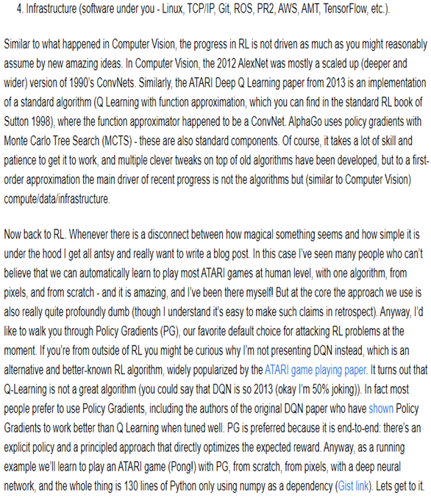

According to Andrej, **PG** is favored due to its **end-to-end nature** and **its ability to directly optimize the expected reward**. He highlights that even the authors of the original DQN paper found PG to be superior to Q Learning under certain conditions.

To demonstrate the effectiveness of PG, Andrej offers to guide readers through the process of using PG to learn to play an ATARI game, specifically Pong, starting from scratch and using a deep neural network.

He reassures readers that this entire process can be accomplished with just 130 lines of Python code, with numpy as the only dependency. Let's delve into the nuances of Policy Gradients and uncover the simplicity behind RL's remarkable achievements!

**Empowering the Next Generation**

In sharing his insights and experiences, Andrej hopes to empower the next generation of AI researchers and enthusiasts. By breaking down complex topics into digestible explanations and real-world examples, he aims to inspire curiosity and exploration.

Whether readers are high school students, college undergraduates, or seasoned professionals, Andrej's blog serves as a valuable resource for demystifying AI and encouraging hands-on experimentation.

**Looking Ahead**

As the field of AI continues to evolve, Andrej encourages readers to embrace the challenge of understanding and applying RL techniques.

By leveraging computational resources, harnessing vast amounts of data, and developing robust infrastructure, researchers can push the boundaries of what's possible in AI.

With a blend of curiosity, creativity, and perseverance, the future of AI holds endless possibilities.

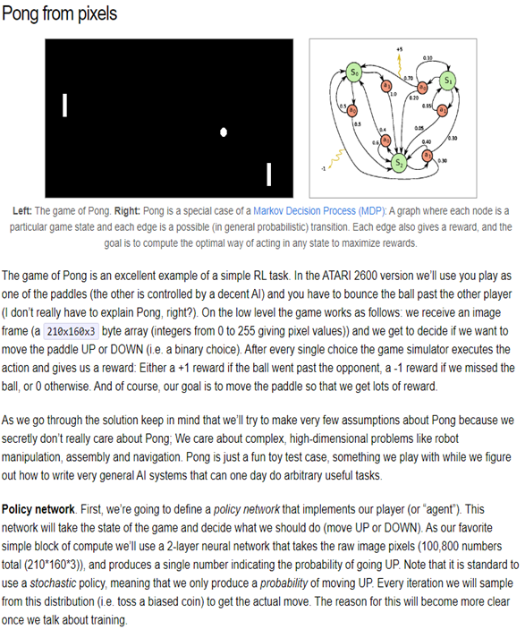**Prompt1:**

**Elaborate this further by breaking down any AI terminologies used here to more simpler explanations**

**Prompt2:**

**What is policy network here, again my reader has zero knowledge about AI terminologies, so I want you to explain everything in an elaborated and simple manner**

**Title :Understanding Pong as a Reinforcement Learning Task**

Pong, a classic arcade game, offers a fantastic opportunity to grasp the concept of Reinforcement Learning (RL). In this game, you control one of the paddles, attempting to bounce the ball past your opponent. The game rewards you with points: +1 for scoring, -1 for missing, and 0 otherwise.

Your aim is to maximize these rewards by deciding when to move the paddle UP or DOWN based on the game's current situation.

**Breaking Down Game Mechanics**

Pong operates on a straightforward principle: you receive an image frame depicting the game state and decide whether to move the paddle UP or DOWN. This decision-making process boils down to a binary choice, meaning you have only two options.

After each decision, the game responds with feedback in the form of rewards. Your objective is to strategically navigate these decisions to earn the highest rewards possible.

**Placing Pong into Context**

Although Pong appears simple, it serves as a valuable model for understanding complex RL problems. Beyond the game itself, RL techniques find applications in various real-world challenges, such as robotics, assembly lines, and navigation systems.

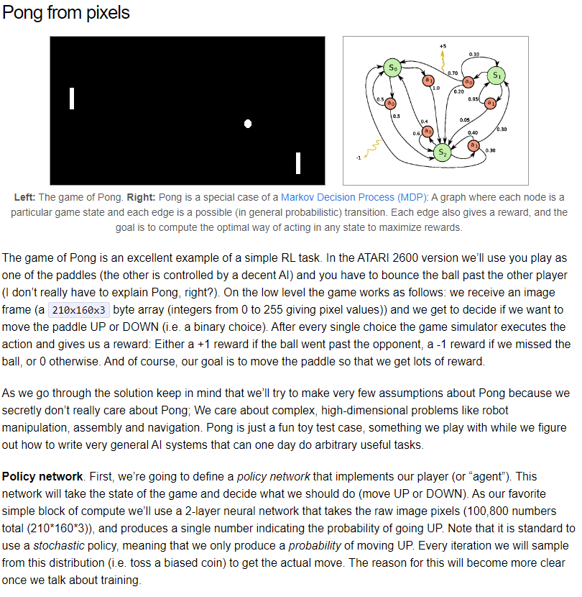By mastering the principles of Pong, we pave the way for developing AI systems capable of tackling intricate tasks in diverse environments.

**Crafting the Policy Network**

To create our player or "agent" in Pong, we require a policy network capable of decision-making based on the game state. This network takes raw image pixels of the game frame as input and predicts the probability of moving UP.

For this task, we employ a 2-layer neural network, a fundamental yet potent computational tool. Through training this network, our goal is to empower our agent to make informed decisions across various game scenarios.

**Understanding the Policy Network:**

In the context of playing Pong, a policy network acts like the brain of our player or "agent." Its job is to decide what action the player should take based on what it sees on the screen.

Think of it as a guide that tells our player whether to move the paddle UP or DOWN.

**How the Policy Network Works:**

When we talk about taking in "raw image pixels," we're referring to the visual information that makes up the game screen. This includes all the colors and shapes you see when playing Pong.

The policy network analyzes these pixels and makes a prediction: should the player move UP or DOWN to best respond to the current situation?

**Using a Neural Network:**

A neural network is a mathematical model inspired by the human brain. It's made up of layers of interconnected nodes that process and analyze data.

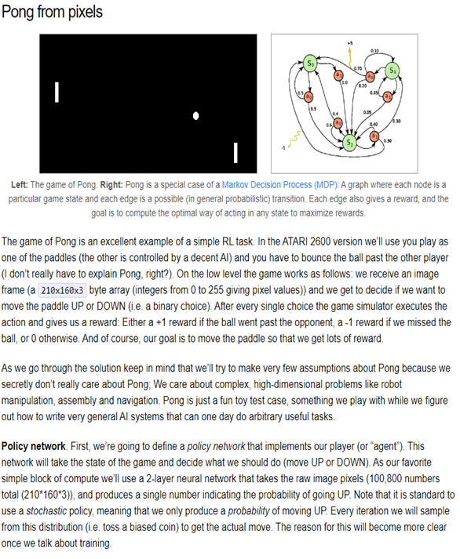In our case, we're using a specific type called a "2-layer neural network." This means we have two layers of nodes that work together to understand the game screen and make decisions.

**Training the Policy Network:**

To teach our agent how to play Pong effectively, we need to train the policy network. This involves showing it many examples of gameplay and letting it learn from experience.

By adjusting the connections between its nodes, the network gradually improves its ability to make accurate predictions. Our goal is to train the network so that our agent can make smart decisions in any situation it encounters during the game.

**In Summary:**

A policy network is like the brain of our player in Pong. It analyzes the visual information from the game screen and decides whether to move the paddle UP or DOWN. Using a neural network, we train the policy network to make better decisions over time, ultimately helping our agent become a skilled player capable of winning the game.

**Prompt3:**

**What is the difference between a Neural Network and a Policy network then?**

Let's clarify the difference between a neural network and a policy network:

**Neural Network:**

A neural network is a computational model inspired by the structure and function of the human brain. It consists of interconnected nodes arranged in layers.

Each node performs simple mathematical operations on the input data and passes the result to the next layer. Through a process called training, the network learns to recognize patterns and make predictions based on the input data.

In general, a neural network can be used for various tasks, such as image recognition, language processing, and prediction. It's a versatile tool in machine learning and artificial intelligence, capable of solving a wide range of problems.

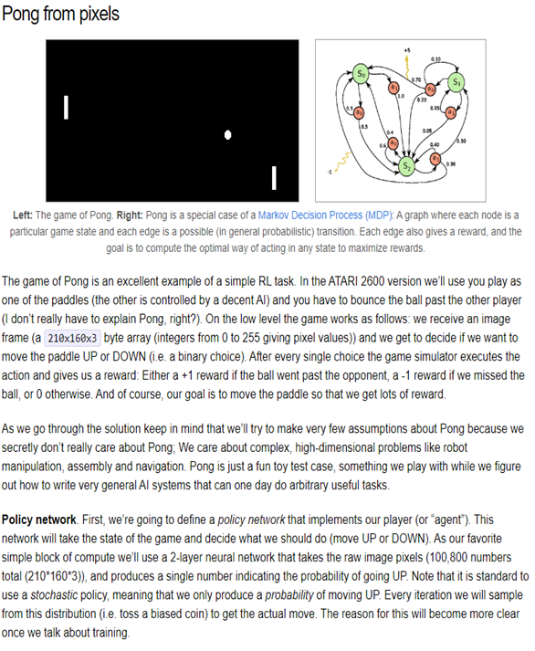

**Policy Network:**

On the other hand, a policy network is a specific type of neural network used in the context of reinforcement learning. Its purpose is to determine the optimal action to take in each situation to maximize the expected reward.

In simpler terms, while a neural network is a general computational model used for various tasks, a policy network is specialized for decision-making in reinforcement learning scenarios. It takes in data about the current state of the environment and outputs the best action to take based on that information.

In summary, a policy network is a type of neural network designed specifically for decision-making in reinforcement learning, whereas a neural network is a more general computational model used for a wide range of tasks in machine learning and artificial intelligence.

**Learning through Exploration:**

Karpathy emphasizes the importance of exploration in reinforcement learning. Rather than relying on pre-defined strategies, our agent explores different actions to discover the most effective gameplay strategies.

Through this process of trial and error, the agent learns which actions lead to favorable outcomes and refines its decision-making abilities accordingly.

Exploration is a fundamental aspect of reinforcement learning, enabling our agent to adapt to changing game scenarios and improve its performance over time.

In summary, the excerpt from Karpathy's blog provides valuable insights into the application of reinforcement learning principles to the game of Pong. By understanding concepts such as Markov Decision Processes, policy networks, reward structures, and exploration, we gain a deeper appreciation for the challenges and opportunities presented by reinforcement learning in both gaming 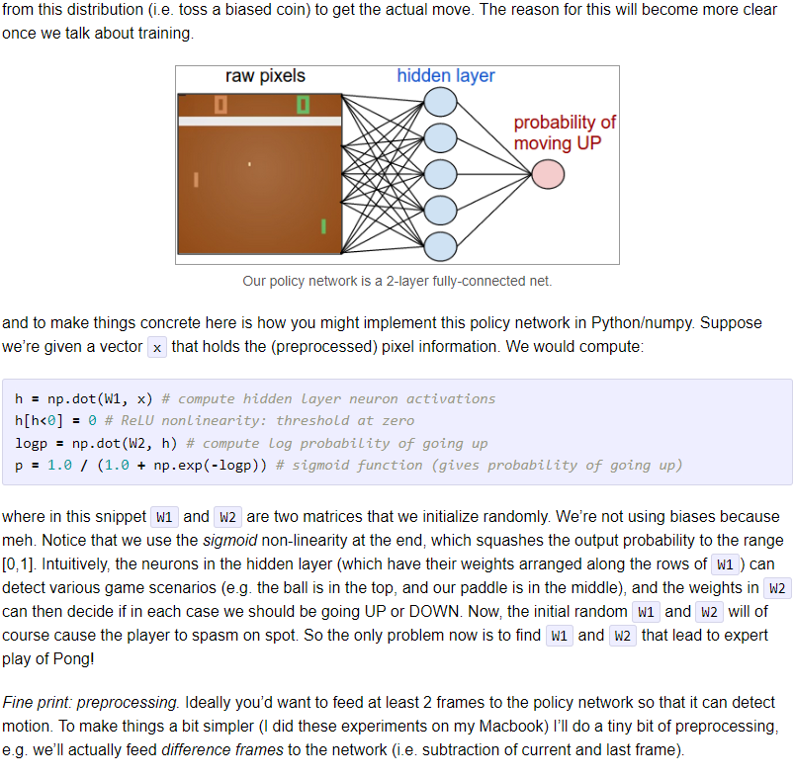and real-world scenarios.

**Prompt:**

**Suggest me prompts that I should feed you, in order to obtain more quality, simpler and elaborated explanations compared to above**

**Explaining "Tossing a Biased Coin":**

Imagine you're flipping a coin, but this coin isn't fair like the ones you use to make decisions. Instead, it's biased, which means it's more likely to land on one side than the other.

In the context of decision-making in the game, tossing a biased coin represents making a choice, like whether to move the paddle up or down, based on probabilities rather than certainty. So, each time the game needs to make a decision, its "tosses" this biased coin to determine the action with a higher probability.

The picture on the left side depicts our policy network as a 2-layer fully connected net.

**Breaking Down Policy Network Implementation:**

Implementing a policy network is like training a friend to play a game by showing them different scenarios and letting them decide what move to make next.

The network receives information about the game, like where the ball is and where the paddle is and uses this data to predict whether to move the paddle up or down.

It's like how you might learn to play a new game by watching others and deciding your moves based on what you see.

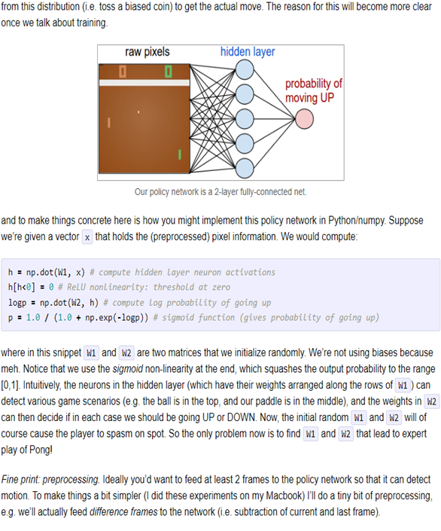**Understanding Weight Matrices:**

Weight matrices are like recipe books for the policy network. They contain instructions (weights) on how to combine the ingredients (input data) to get the desired outcome (decision). Think of them as sets of rules that the network follows to process information and make decisions.

Each weight matrix guides a specific part of the decision-making process, like deciding whether to move the paddle up or down based on different game scenarios.

**Describing Preprocessing for Motion Detection:**

Preprocessing for motion detection is like comparing two pictures to see if anything has changed. Imagine taking a photo of your room and then taking another photo a few seconds later.

By looking at the differences between these two pictures, like if something has moved or changed position, you can detect motion. In the game, preprocessing involves analyzing changes between consecutive frames to understand how things are moving.

**Simplifying ReLU and Sigmoid Functions:**

ReLU and sigmoid functions are like filters that help the network make sense of the information it receives. ReLU function decides if something is important or not by saying "yes" if it's positive and "no" if it's negative. Sigmoid function squeezes the information into a range between 0 and 1, like squeezing toothpaste from a tube, to represent probabilities.

**Explaining the Absence of Biases:**

Biases are like shortcuts that the network can take to make decisions. By not using biases, we're forcing the network to rely solely on the information it receives, making the decision-making process more transparent and straightforward.

This simplifies the explanation because we don't have to consider additional factors that biases introduce.

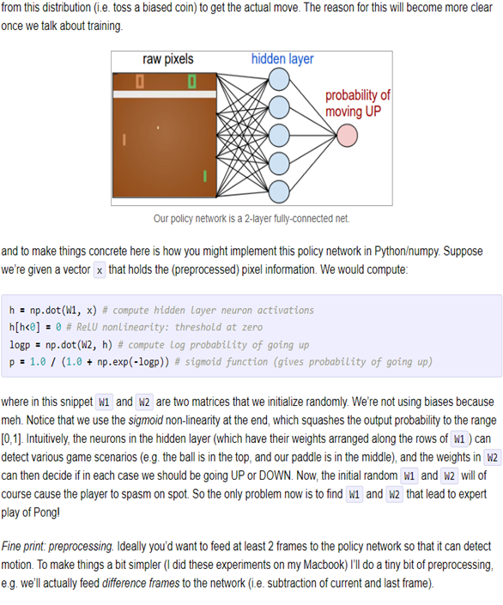**Understanding Decision-making in the Policy Network:**

The policy network makes decisions by considering all the information it has about the game and predicting the best action to take. Randomness is important in this process because it introduces variability, allowing the network to explore different strategies and learn from its experiences. Just like trying different approaches in a game to see which one works best.

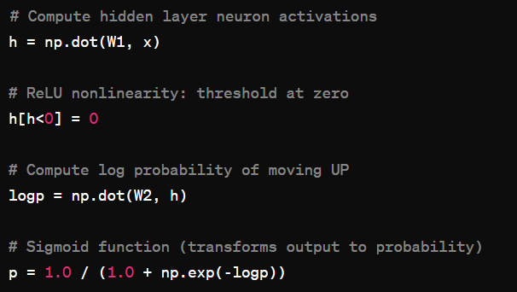

**Compute Hidden Layer Activations:**

We start by calculating the activations of the hidden layer neurons. Imagine this as a way for the neural network to understand patterns in the input data. Each neuron in the hidden layer receives input from all the pixels in the image represented by vector x.

The term "**hidden layer activation**" refers to the result of applying an activation function to the dot product of W1 and x. In the code snippet provided, after computing the dot product h = np.dot(W1, x), the ReLU activation function is applied elementwise to the resulting array h.

This means that for each element in h, if the value is less than zero, it's set to zero, and if it's greater than or equal to zero, it remains unchanged. This process transforms the raw output of the dot product 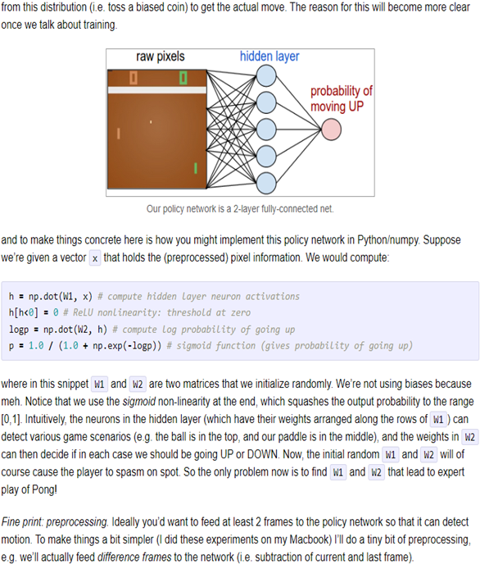into the hidden layer activations, which are then passed on to the next layer of the neural network for further processing. So, "hidden layer activation" encompasses both the dot product operation and the subsequent application of the activation function.

The operation np.dot(W1, x) involves multiplying the input data x by a set of weights W1, which is essentially a learned matrix of parameters. This multiplication sums up the contributions of each pixel in the image to the activation of each neuron in the hidden layer.

In neural networks, combining the input data with weights is a crucial step because it allows the model to learn and adapt to patterns in the data. Here's why this step is essential:

When we compute the dot product of W1 and x, we obtain activations for neurons in the hidden layer of the neural network. Each neuron in the hidden layer represents a different possibility or combination of features extracted from the input data x.

The dot product essentially combines the information from the input with the learned weights in W1, producing activations that capture the relationships between the input features and the hidden neurons.

These activations serve as inputs to the next layer of the neural network, allowing for further processing and ultimately leading to the generation of predictions or decisions by the model.

**Weighted Sum:**

Each input feature is multiplied by a corresponding weight. These weights determine the importance of each feature in predicting the output. For example, in image recognition, certain pixels may be more relevant than others in identifying specific objects.

**Capturing Relationships:**

By adjusting these weights during the training process, the neural network learns to capture complex relationships between input features and the target output.

For instance, in a language model, certain words may have more significance in determining the sentiment of a sentence.

**Flexibility:**

****The ability to adjust weights allows the neural network to adapt to different datasets and tasks. As the model learns from examples, it fine-tunes the weights to minimize prediction errors and improve performance.

**ReLU Nonlinearity:**

The ReLU (Rectified Linear Unit) function introduces nonlinearity into the network by setting all negative values in the hidden layer activations (h) to zero. This step helps the network learn more complex patterns in the data by allowing it to model nonlinear relationships.

"**Non-linearity**" refers to the property of a system or function where the output is not directly proportional to the input. In simpler terms, it means that the relationship between the input and output is not a straight line.

**Compute Log Probability:**

Next, we calculate the log probability of moving UP using another matrix multiplication operation (np.dot(W2, h)). The weights W2 represent another set of learned parameters that transform the hidden layer activations into the log probabilities of taking the UP action.

This step is necessary because it computes the weighted sum of the hidden layer activations (stored in variable h) with another set of weights represented by W2.

This operation helps in transforming the information learned in the hidden layer into the final output, which in this case is the log probability of moving up in the game.

It's a crucial step in the neural network's decision-making process, as it determines the likelihood of taking a specific action based on the current state of the game.

The term "**log probability**" in this context **doesn't actually involve the computation of logarithms**. It's a **common convention** in machine learning to refer to the output of the last layer before applying the activation function as the log probabilities.

This term is used because the output values are often transformed into probabilities using the sigmoid or softmax function, and taking the logarithm of these probabilities is a common operation in certain mathematical calculations. However, in this specific code snippet, the log probabilities are not directly computed; rather, the term logp represents the raw output before the sigmoid function is applied.

**Sigmoid Function:**

The sigmoid function 1.0 / (1.0 + np.exp(-logp)) transforms the log probability into a probability value between 0 and 1. This step ensures that the output represents a valid probability of taking the UP action. The higher the probability, the more likely the network will decide to move the paddle UP.

**Purpose:**

The sigmoid function is used to transform the raw output of the neural network into a probability value. In the context of the policy network, this transformed probability represents the likelihood of taking a specific action, such as moving the paddle UP in the game of Pong.

**What it does:**

The sigmoid function maps any real-valued number to the range [0, 1]. This is crucial because probabilities must fall within this range, with 0 indicating impossibility and 1 indicating certainty.



In a nutshell, the sigmoid function transforms the raw output of the policy network into a probability value by applying a mathematical formula that ensures the output falls within the valid probability range. This transformation is essential for making informed decisions in the game of Pong based on the network's predictions.

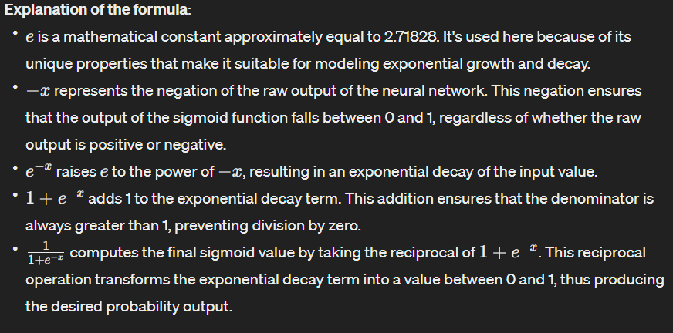

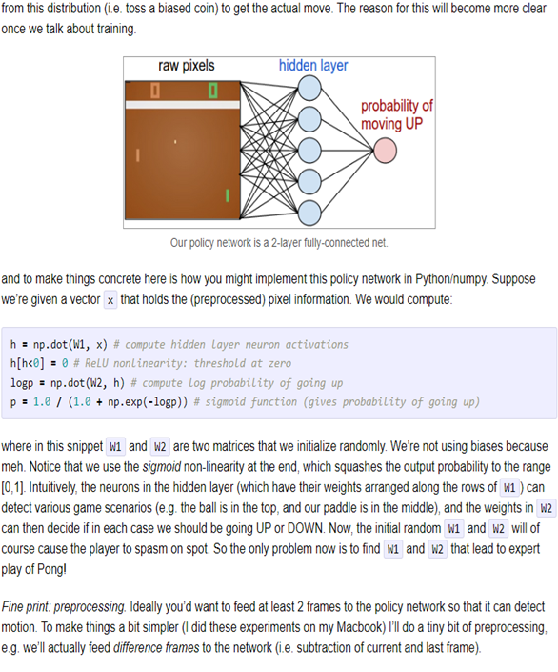

In summary, this code snippet demonstrates how a neural network, represented by matrices W1 and W2, processes input data (x) to produce a probability of moving the paddle UP in the game of Pong.

The network learns to associate different patterns in the game state with the likelihood of taking specific actions, ultimately aiming to maximize its rewards over time.

In implementing a policy network, the process begins with taking preprocessed pixel information from the game environment as input. This data represents the current state of the game.

The network then computes the activations of hidden layer neurons, each of which represents different aspects or features of the game state. Through the application of ReLU activation, the network introduces non-linearity to these neuron activations.

Following this, the network computes the log probabilities of possible actions, such as moving the paddle UP. These raw probabilities are then transformed into probabilities using the sigmoid function, squashing the output values into a range of [0,1].

Subsequently, the network samples from this probability distribution to determine the actual action to take in the game. Throughout training, the network adjusts the weights of its connections to optimize decision-making, aiming to maximize the cumulative reward obtained during gameplay.

This iterative process allows the policy network to learn and improve its performance over time.

**Prompt:**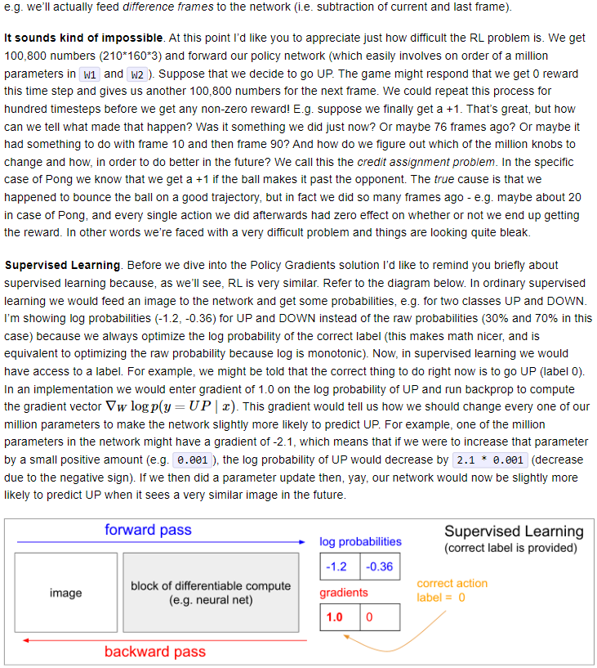

**Now I am pasting the next page. Get ready to explain how you have explained before. I had to repeatedly ask you to breakdown the concepts and AI terminologies used again and again, this time when you generate the explanation do it all for me as if I have zero knowledge about the AI terminologies.**

1. **Difference Frames:**

* This concept involves processing consecutive frames of an environment (e.g., a game like Pong) by subtracting the pixel values of the current frame from the pixel values of the previous frame.
* For example, if we have two frames of the game, we subtract the pixel values of the previous frame from the current frame to highlight the changes or differences between them.
* This technique is used to capture motion or changes in the environment over time, which can be crucial for decision-making in reinforcement learning tasks.

1. **Credit Assignment Problem:**

* In reinforcement learning, the credit assignment problem refers to the challenge of determining which actions or decisions contributed to a particular outcome or reward received by the agent.
* In the context of playing Pong, where the reward (+1) is only received after the ball passes the opponent, it can be difficult to attribute this reward to specific actions taken by the agent.
* This problem becomes more complex when there is a delay between taking an action and receiving a reward, as multiple actions may influence the outcome over time.

1. **Supervised Learning:**

* Supervised learning is a machine learning paradigm where the model is trained on labeled data, with each input associated with a corresponding output label.
* 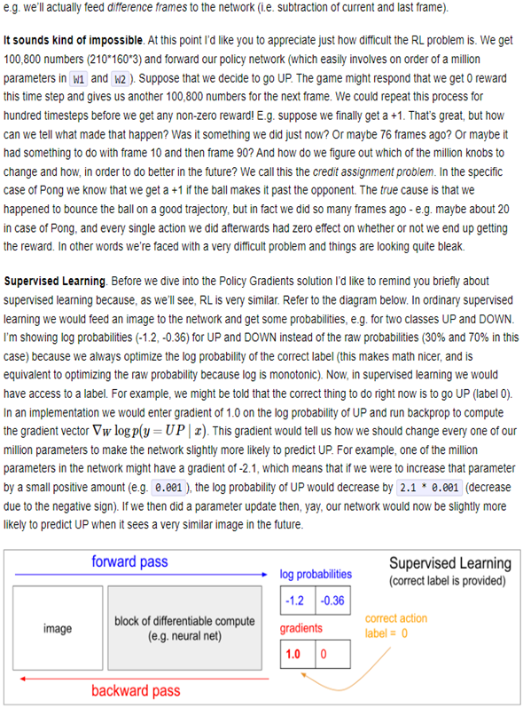In the context of the provided explanation, supervised learning is contrasted with reinforcement learning, highlighting similarities between the two approaches.
* In supervised learning, the model learns to map inputs to outputs based on labeled examples provided during training, whereas in reinforcement learning, the agent learns to make decisions to maximize cumulative rewards through interaction with an environment.

1. **Backpropagation (Backprop):**

* Backpropagation is a fundamental algorithm used to train neural networks by efficiently computing gradients of the loss function with respect to the network's parameters.
* It involves propagating the error or loss backwards through the network, computing gradients at each layer, and using these gradients to update the network parameters via optimization algorithms like gradient descent.
* In the context of supervised learning, backpropagation is used to adjust the network parameters to minimize the discrepancy between predicted and true labels in the training data.

In our case we are going to be using Policy Gradients instead of Backpropagation as it specifically used for Reinforcement Learning and Backpropagation primarily is used for supervised learning.

1. **Policy Gradients:**

* This is a method used in reinforcement learning, where an agent learns to interact with an environment in order to maximize cumulative rewards. Policy gradient methods update the parameters of a policy network based on the gradients of the expected cumulative reward with respect to the policy parameters. This allows the agent to learn a policy that selects actions to maximize expected long-term rewards.

1. **Log Probability:**

* Log probability refers to the natural logarithm of the probability of an event occurring.
* In machine learning, log probabilities are often used because they offer numerical stability and are easier to handle mathematically, especially when dealing with small probabilities or likelihoods.
* 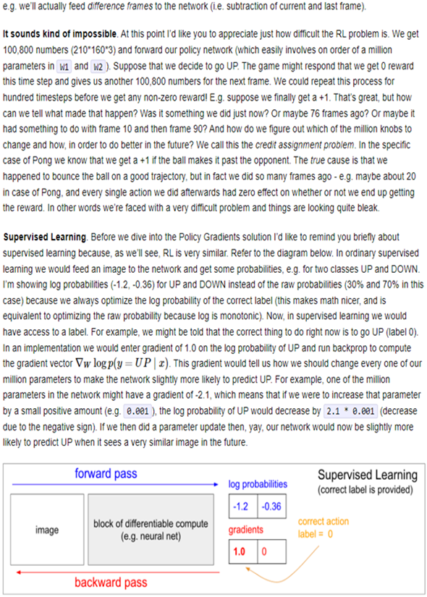In the context of training neural networks, optimizing log probabilities of predicted outcomes (e.g., actions) helps in maximizing the likelihood of correct predictions and improving model performance.

1. **Gradient Descent:**

* Gradient descent is an optimization algorithm used to minimize a loss function by iteratively adjusting the parameters of a model in the direction of the steepest descent of the loss surface.
* It involves computing the gradients of the loss function with respect to the model parameters and updating the parameters in the opposite direction of the gradient, scaled by a learning rate.
* Gradient descent is a key component of training neural networks in both supervised and reinforcement learning settings, helping models converge towards optimal parameter values.

**Prompt:**

**OK good you have explained the terminologies, now go ahead, and explain the content in paragraphs as a nutshell.**

The text illustrates the intricate nature of reinforcement learning (RL) by examining the game Pong as a case study. It underscores the challenge of RL, particularly the credit assignment problem, where determining which actions lead to rewards becomes convoluted due to delayed feedback.

This challenge is vividly depicted by the example of bouncing a ball in Pong, where the reward might be attributed to actions taken several frames ago, making it arduous to discern causality.

Moreover, the text draws parallels between RL and supervised learning, shedding light on their similarities. Supervised learning, which involves training a model on labeled data, is contrasted with RL, where the agent learns through trial and error based on rewards received from the environment.

Backpropagation, a key algorithm in training neural networks for supervised learning, is briefly mentioned, hinting at its importance in optimizing models for RL tasks.

The discussion extends to the preprocessing of game frames, where techniques such as frame differencing are employed to detect motion. By subtracting consecutive frames, the network can focus on changes in the environment, such as the movement of objects, aiding in decision-making.

Additionally, the text introduces the concept of log probabilities in neural network optimization. By optimizing the log probability of correct predictions, gradient descent algorithms can efficiently update model parameters to improve performance.

This optimization process, fundamental to both supervised learning and RL, forms the backbone of neural network training.

In essence, the content provides a comprehensive overview of RL principles, highlighting challenges, parallels with supervised learning, preprocessing techniques, and optimization strategies. Through the lens of Pong, it offers insights into the complexities of RL tasks and the underlying mechanisms driving learning and decision-making in neural networks.

**Backpropagation** is a crucial algorithm used in training neural networks. In simple terms, it's like a feedback loop where the network adjusts its internal parameters (weights and biases) based on how well it's performing in a given task. **Here's how it works:**

**Forward Pass:** During the forward pass, the input data is fed into the neural network, and computations are made through each layer, producing an output.

**Compute Loss:** The output of the network is compared to the actual target or expected output, resulting in a loss value. This loss represents how far off the network's predictions are from the true values.

**Backward Pass (Backpropagation):** In this step, the algorithm calculates the gradient of the loss function with respect to each parameter in the network, using a technique called the chain rule from calculus. This gradient essentially tells us how much each parameter contributes to the error.

**Parameter Update:** With the gradients calculated, the network updates its parameters (weights and biases) in the opposite direction of the gradient, a little bit at a time. This is done to minimize the loss function, moving the network towards better performance.

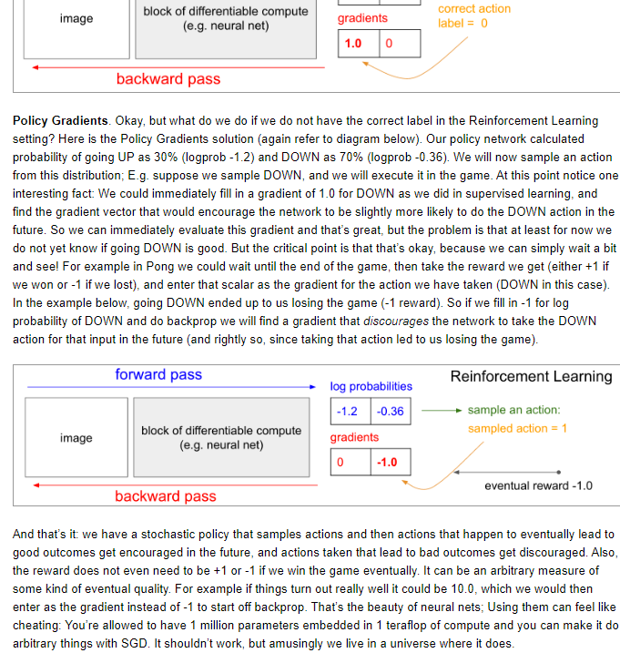**Iteration:** The process repeats for many iterations (epochs), with the network making incremental adjustments to its parameters based on the feedback from the training data.

Through this iterative process, backpropagation allows neural networks to learn from data, gradually improving their ability to make accurate predictions or perform tasks.

**Prompt:**

**Now I am pasting the next page. Get ready to explain how you have explained before. I had to repeatedly ask you to breakdown the concepts and AI terminologies used again and again, this time when you generate the explanation do it all for me as if I have zero knowledge about the AI terminologies. Wait for me to paste the content**

Let's break down the concept of Policy Gradients in a simpler way. Imagine you're playing a game like Pong, and you're trying to figure out the best strategy to win. In Policy Gradients, instead of knowing the best move beforehand (like in supervised learning), we're going to try different moves randomly and then learn from the outcomes.

So, let's say our policy network predicts that there's a 30% chance we should move UP and a 70% chance we should move DOWN. We randomly pick a move based on these probabilities, let's say we choose to move DOWN. Now, at this point, we don't know if moving DOWN is good or bad for winning the game.

But that's okay because we can wait and see what happens next. Maybe moving DOWN leads to winning (+1 reward) or losing (-1 reward).

We use this reward (or punishment) to adjust our policy. If moving DOWN led to losing the game, we give a negative reward for choosing DOWN, and our policy network learns to be less likely to choose DOWN in similar situations in the future.

In other words, our policy network learns from experience: actions that lead to good outcomes are encouraged, while actions that lead to bad outcomes are discouraged. And the reward doesn't have to be just +1 or -1; it can be any measure of success or failure, like 10.0 for a very successful outcome.

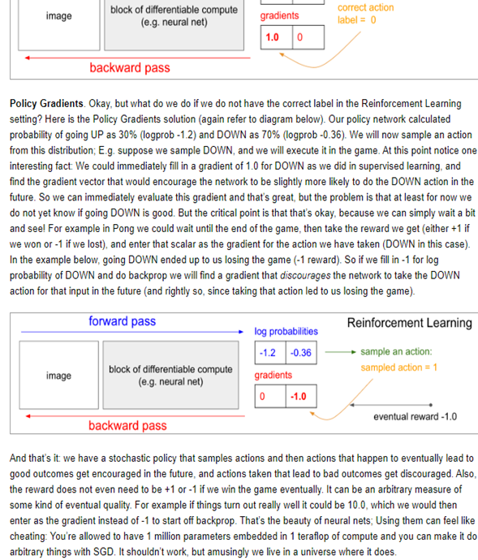This approach may seem a bit magical because we're using neural networks to learn from trial and error, but it's a powerful technique that allows us to solve complex problems without needing to know the best solution beforehand.

**Question is…. Is it done Randomly ?**

No, it's not entirely random. The policy network predicts the probabilities of different actions based on the current state of the game. So, it's making an educated guess about which action is most likely to lead to a good outcome.

However, because we're dealing with uncertain environments and imperfect information, there's always some level of randomness involved in selecting actions. This randomness helps explore different strategies and learn from the outcomes.

The policy network, based on its training and the current state of the game, assigns probabilities to each possible action.

These probabilities are not random; they're calculated based on the network's understanding of the game environment and its past experiences. The network tries to estimate which action is most likely to result in a positive outcome, such as winning a point in Pong.

However, because the environment is dynamic and uncertain, the network's predictions aren't always perfect.

To account for this uncertainty and to explore alternative strategies, the policy network adds a level of randomness when selecting actions.

This randomness allows the agent to try out different actions, even ones that the network might not initially predict as the best choice. Through this exploration, the agent can learn from the outcomes of different actions and improve its decision-making over time.

**What is meant by stochastically samples actions ??**

In simple terms, imagine you're playing a game where you have a few different moves you can make, like going up, down, left, or right. Each move has a chance of being the best one to make, depending on the situation in the game.

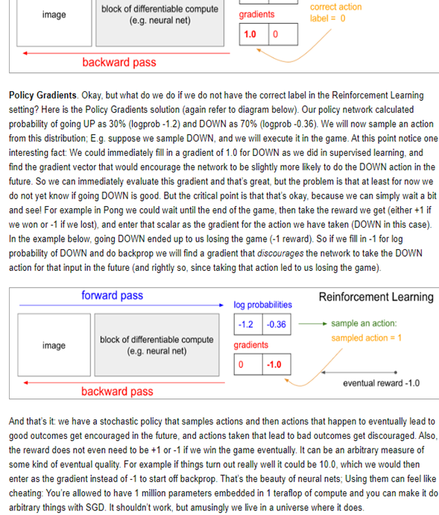Now, instead of always picking the move that seems best based on what you know, you decide to mix things up a bit.

You randomly choose your move each time, but you do it in a clever way: you give each move a higher chance of being picked if it seems like a better choice.

For example, if going up usually leads to good outcomes in the game, you'll give the "up" move a higher chance of being picked when you randomly choose. But you'll still leave a little room for picking the other moves sometimes, just to see what happens.

This randomness in your decision-making process is what we mean by "stochastically sampling actions." It's like rolling a dice to decide which move to make, but the dice is weighted in favor of the moves that usually work well.

This helps you explore different strategies and learn from your experiences in the game.

When it starts out, it randomly tries different actions to see what happens. But as it goes along and sees the outcomes of those actions, it learns which ones tend to lead to good results.

Then, in the future, it's more likely to choose the actions that have worked well in the past. So, it's like learning from experience and using that knowledge to make better decisions over time.

In Summary, in this section we delved into the concept of Policy Gradients in Reinforcement Learning (RL), a fascinating approach where the system learns to make decisions by trial and error.

Unlike supervised learning where we have clear labels for correct actions, in RL, the correct action isn't known beforehand. Instead, the system samples actions stochastically based on the probabilities calculated by the policy network.

These actions are then executed, and their outcomes are observed. Over time, the network learns from these outcomes, reinforcing actions that lead to positive results and discouraging those that don't.

This iterative process of exploration and learning allows the system to gradually improve its decision-making abilities without needing explicit guidance.

It's a remarkable demonstration of how neural networks can adapt and optimize their behavior based on feedback from the environment, ultimately achieving complex tasks through seemingly simple yet powerful mechanisms.

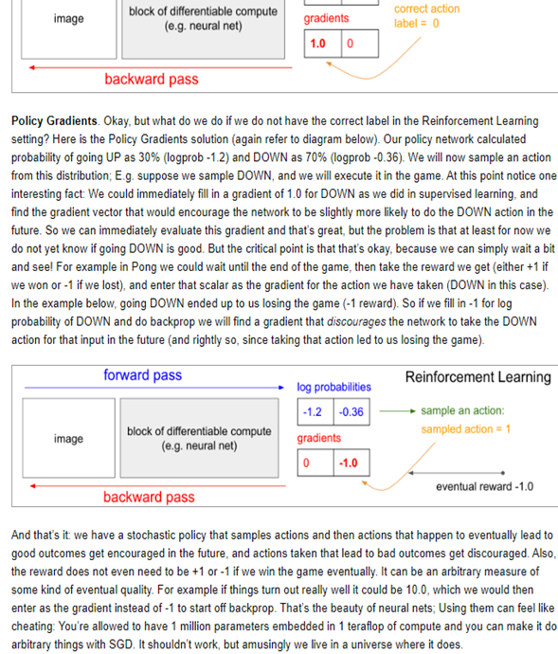To **implement policy gradients**, we use a neural network as the "brain" of our robot. This neural network takes the current situation in the game (like the positions of objects) as input and outputs the probability of taking different actions (like moving up, down, left, or right).

Here's how it works:

**Collect Data:** We let the robot play the game multiple times, making decisions based on its current policy (the current strategy it follows).

**Evaluate Performance:** After each game, we look at the outcomes of the moves the robot made. If it won, we consider those moves good; if it lost, we consider them bad.

**Update Policy:** We then update the neural network's parameters to make the good moves more likely in the future and the bad moves less likely. We do this by adjusting the weights of the neural network through a process called backpropagation, which essentially nudges the network in the right direction based on its performance.

**Repeat:** We repeat this process many times, letting the robot play, evaluating its performance, and updating its strategy, until it gets better and better at the game.

So, essentially, we're using the neural network to learn from experience, gradually improving its decision-making abilities over time.

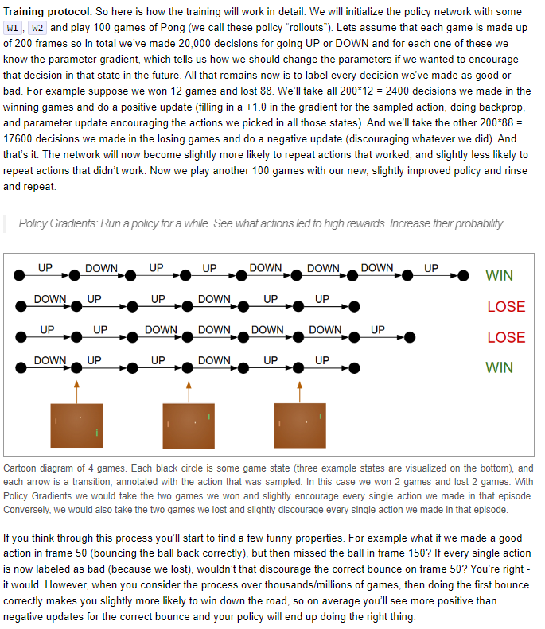**Prompt:**

**Now I am pasting the next page. Get ready to explain how you have explained before. I had to repeatedly ask you to breakdown the concepts and AI terminologies used again and again, this time when you generate the explanation do it all for me as if I have zero knowledge about the AI terminologies. Wait for me to paste the content**

Training the policy network involves a systematic process of iteratively refining its decision-making capabilities. By playing multiple games of Pong and evaluating the outcomes, the network gradually learns which actions lead to favorable results and which ones do not.

Each game consists of numerous decisions, such as whether to move the paddle up or down in response to the ball's movement. These decisions are made based on the current state of the game and the policy network's learned probabilities for each action.

After playing a set number of games, the network evaluates its performance and updates its parameters accordingly. Positive outcomes, such as winning a game, result in adjustments that increase the likelihood of repeating the actions that led to success.

Conversely, negative outcomes, such as losing a game, prompt adjustments that decrease the likelihood of repeating the actions that contributed to failure. This process of reinforcement allows the network to learn from its experiences and improve its decision-making over time.

The policy network's parameters, represented by matrices W1 and W2, are updated using a technique known as backpropagation. This involves computing the gradient of the loss function with respect to each parameter and adjusting the parameters in the direction that minimizes the loss.

Policy gradients provide a principled approach to reinforcement learning, allowing the network to learn directly from its interaction with the environment. Instead of relying on explicit labels or rewards, the network learns to maximize cumulative rewards through trial and error.

****The stochastic nature of policy gradients enables the network to explore different strategies and adapt to changing conditions. By sampling actions from the learned policy distribution, the network can explore alternative courses of action and learn from both successful and unsuccessful attempts.

Despite the challenges posed by the credit assignment problem, policy gradients offer an effective solution by providing feedback based on the overall success or failure of an episode. This allows the network to focus on actions that contribute most to the desired outcomes.

During training, the policy network seeks to strike a balance between exploration and exploitation. While exploration involves trying out new actions to discover potentially better strategies, exploitation involves leveraging known strategies to maximize immediate rewards.

The iterative nature of policy gradient training allows the network to continually refine its decision-making strategies based on feedback from the environment. This process of learning from experience enables the network to adapt to changing conditions and improve its performance over time.

Policy gradients offer a flexible and scalable framework for training reinforcement learning agents. By leveraging the principles of stochastic sampling and gradient descent, these methods enable the network to learn optimal policies in complex and dynamic environments.

The success of policy gradient methods hinges on their ability to effectively balance exploration and exploitation. By sampling actions from the learned policy distribution, the network can explore alternative strategies while still exploiting known good actions.

Despite the inherent uncertainty and complexity of reinforcement learning tasks, policy gradients offer a principled approach to learning from experience. By iteratively adjusting the policy based on feedback from the environment, the network can gradually improve its decision-making abilities.

The use of policy gradients in reinforcement learning reflects a shift towards more data-driven and adaptive approaches to artificial intelligence. Instead of relying on handcrafted rules or heuristics,

policy gradient methods learn directly from experience, allowing for more robust and adaptive behavior.

In summary, policy gradients provide a powerful framework for training reinforcement learning agents in complex and dynamic environments. By enabling the network to learn directly from its ****interaction with the environment, policy gradient methods offer a principled and effective approach to artificial intelligence.

The training protocol outlined in the text provides a detailed framework for implementing policy gradients in reinforcement learning.

By initializing a policy network with certain parameters and conducting multiple rounds of gameplay, the network gradually learns to associate actions with rewards through stochastic sampling and backpropagation.

The process involves exploring different actions, evaluating their outcomes, and updating the network parameters accordingly.

Despite challenges such as the credit assignment problem, where it may be difficult to attribute rewards to specific actions, the overall approach leverages gradient descent and optimization techniques to improve the policy over time.

Through this iterative process of exploration and exploitation, the network becomes more adept at making decisions that lead to favorable outcomes in the given environment.

Ultimately, the goal is to develop intelligent agents capable of learning and adapting to complex tasks and environments through reinforcement learning methods.

**Gradient Descent explained with a simple example:**

Gradient descent is like walking down a hill blindfolded, using only your sense of touch to feel the slope beneath your feet. Imagine you're on a mountain, and your goal is to reach the lowest point possible. At each step, you feel the slope beneath you and take a small step downhill.

The steeper the slope, the bigger your step. This process repeats until you can't go downhill anymore, meaning you've reached a valley, or a minimum point.

In our case, instead of a mountain, we're navigating the landscape of our loss function, trying to minimize it by iteratively adjusting our parameters in the direction of the negative gradient.

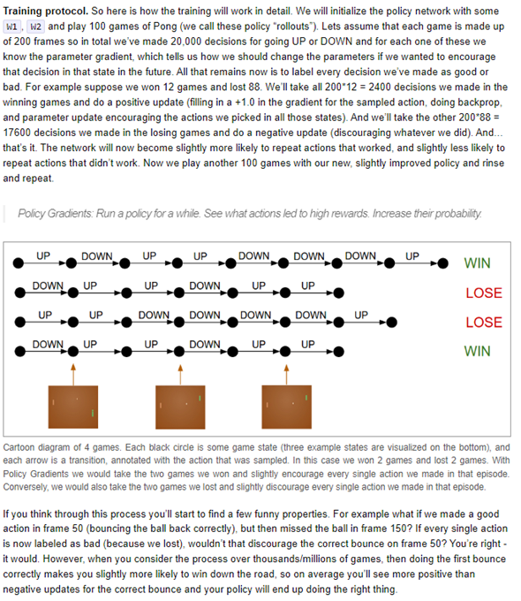When we talk about "weighting" in the context of reinforcement learning, we're essentially assigning a level of importance or preference to different actions based on certain criteria. In this case, the weighting of actions refers to how likely each action is to be chosen or sampled during the decision-making process.

Actions that are more favorable or have a higher probability of leading to positive outcomes are assigned a higher weight, making them more likely to be selected. Conversely, actions with lower probabilities or that are less desirable are given lower weights and are less likely to be chosen. This weighting mechanism helps the agent prioritize actions that have a higher expected reward, contributing to more effective decision-making and learning over time.

**What exactly are we doing to implement the weighting?**

To apply weighting to the probabilities of actions, we use a technique called "softmax weighting." Here's how it works:

**Calculate Action Scores:** For each action, we calculate a score based on some measure of its desirability. This measure could be the expected reward associated with the action or some other indicator of its potential success.

**Apply Softmax Function:** Next, we apply the softmax function to these scores. The softmax function takes a set of scores as input and outputs a probability distribution over the actions, ensuring that the probabilities sum to 1. The higher the score relative to other actions, the higher the probability assigned to that action.

**Adjust Probabilities:** After applying the softmax function, actions with higher scores will have higher probabilities, while actions with lower scores will have lower probabilities. This effectively weights the probabilities of actions based on their scores, with more desirable actions having higher probabilities of being selected.

**Sample Action:** Finally, we sample an action from this probability distribution, using techniques like random sampling or stochastic selection, to determine which action the agent will take.

By applying softmax weighting to the action scores, we can adjust the probabilities of actions in a way that reflects their relative desirability, allowing the agent to make more informed decisions in the environment.

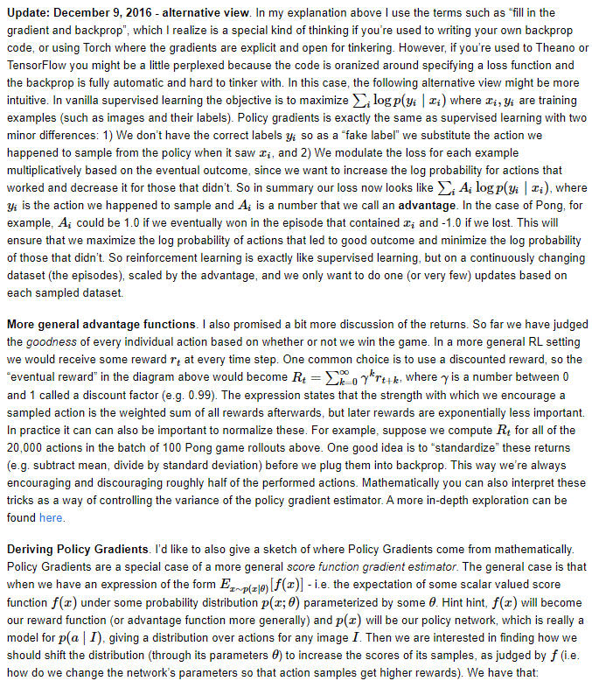in the context of stochastic selection, actions with higher probabilities are more likely to be chosen, but there is still an element of randomness involved. Even though actions with higher probabilities have a greater chance of being selected, there's still a possibility for actions with lower probabilities to be chosen occasionally. This randomness ensures exploration of different actions and prevents the agent from becoming too deterministic in its decision-making process.

**Prompt:**

**Now I am pasting the next page. Get ready to explain how you have explained before. I had to repeatedly ask you to breakdown the concepts and AI terminologies used again and again, this time when you generate the explanation do it all for me as if I have zero knowledge about the AI terminologies. Wait for me to paste the content**

This update introduces an alternative perspective on policy gradients, particularly aimed at those familiar with TensorFlow or Theano frameworks. In vanilla supervised learning, the goal is to maximize the likelihood of correct labels given the input data.

In policy gradients, we don't have explicit labels, so we use the action chosen by our policy network as a "fake label". **Policy gradients** are a technique in reinforcement learning where the objective is to adjust the parameters of a policy network **to maximize rewards**. Instead of using explicit labels as in supervised learning, policy gradients use the outcomes of actions taken by the policy to guide the learning process.

The gradient of the loss function is a vector that represents the rate of change of the loss function with respect to each parameter in the neural network. In simpler terms, it tells us how much the loss would change if we were to make a small change in each parameter. This information is crucial for the backpropagation algorithm, as it guides the network in adjusting its parameters to minimize the loss and improve its performance on the given task.

In the context of the above explanation, "each parameter" refers to the individual values that define the neural network's structure and behavior. These parameters include weights and biases associated with each neuron in the network.

The gradient of the loss function with respect to each parameter indicates how adjusting each parameter affects the overall loss of the network. This information is essential for updating the parameters during the training process to improve the network's performance in solving the given task.

The goal is to increase the probability of actions that lead to positive outcomes (rewards) and decrease the probability of actions that lead to negative outcomes. This approach allows the policy network to learn directly from experience without relying on predefined labels.

The loss function is then adjusted based on the outcome of the action, aiming to increase the likelihood of actions that lead to positive outcomes and decrease the likelihood of those that don't.

This adjusted loss function incorporates an advantage term, denoted as Ai, which represents the effectiveness of the action taken. For instance, in a game like Pong, the advantage could be 1.0 if the action leads to winning and -1.0 if it leads to losing.

This approach effectively transforms reinforcement learning into a form similar to supervised learning, operating on a dynamic dataset (episodes) and optimizing based on the advantages associated with each action.

In a broader reinforcement learning context, rewards are received at each time step rather than just at the end of an episode. One common strategy is to use a discounted reward, which emphasizes the importance of immediate rewards over future ones.

The discounted return, denoted as Rt, represents the cumulative sum of rewards from a given time step onward, with the discount factor γ determining the importance of future rewards.

**So, is Policy Gradient like a machine algorithm?**

No, "policy gradients" is not an algorithm itself; rather, it's a technique used in reinforcement learning algorithms. Specifically, policy gradients refer to a class of algorithms used to train a policy network in reinforcement learning. The objective of these algorithms is to learn a policy that maximizes the cumulative reward obtained by an agent interacting with an environment. So, while "policy gradients" isn't an algorithm on its own, it's a fundamental concept within the field of reinforcement 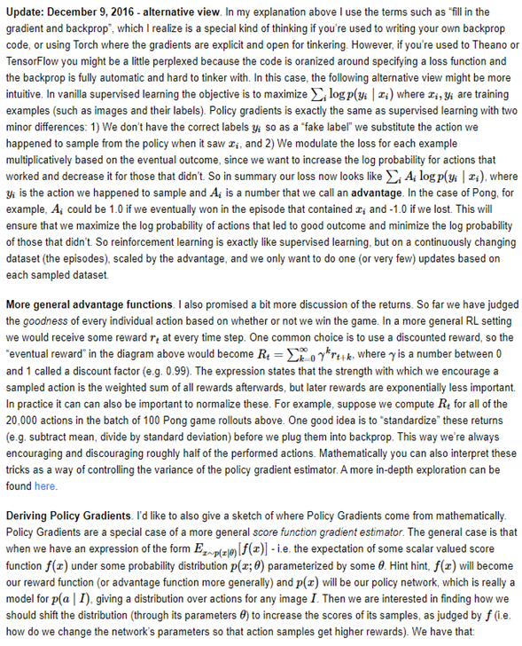learning that guides the development of various algorithms aimed at learning effective decision-making policies.

Policy gradient algorithms use the concept of gradients to update the parameters of a policy network in order to maximize the expected cumulative reward. Here's how it works:

1. **Policy Network:**

* The policy network is a neural network that takes the state of the environment as input and outputs a probability distribution over possible actions.

1. **Exploration:**

* Initially, the policy network may output actions randomly or with some level of exploration to explore different possibilities.

1. **Action Selection**:

* The agent selects actions based on the output probabilities of the policy network. These actions are then executed in the environment.

1. **Reward Collection:**

* After taking actions, the agent receives rewards from the environment based on its actions. These rewards are used to evaluate the quality of the actions taken.

1. **Gradient Calculation:**

* The gradients of the policy parameters are calculated based on the rewards received. The goal is to increase the likelihood of actions that lead to high rewards and decrease the likelihood of actions that lead to low rewards.

1. **Parameter Update:**

* The gradients are used to update the parameters of the policy network through techniques like stochastic gradient descent (SGD). This process encourages the policy network to learn to select actions that maximize expected rewards over time.

1. **Iterative Improvement:**

* The agent continues to interact with the environment, collect rewards, and update the policy network parameters iteratively. Over time, the policy network learns to select actions that lead to higher cumulative rewards, thus improving its performance in the task.

Overall, policy gradient algorithms enable the agent to learn effective decision-making policies by directly optimizing for the expected cumulative reward through gradient-based updates to the policy network parameters.

**So essentially is Policy gradients like a stage in the Backpropagation process?**

Policy gradients and backpropagation are related in the sense that both involve the calculation of gradients to update neural network parameters. However, they serve different purposes and operate in different contexts:

1. **Backpropagation:** This is a technique used primarily in supervised learning to train neural networks. It involves calculating gradients of a loss function with respect to the network parameters and using these gradients to update the parameters in a way that minimizes the prediction error on labeled training data.
2. **Policy Gradients:** This is a method used in reinforcement learning to train agents to make decisions in an environment to maximize cumulative rewards. Policy gradient methods involve calculating gradients of expected cumulative rewards with respect to the parameters of a policy network and using these gradients to update the policy parameters to improve decision-making.

While both techniques involve gradient calculations, they differ in their objectives and the types of problems they address. Policy gradients are not derived from backpropagation; rather, they are a distinct approach tailored to reinforcement learning tasks. However, some reinforcement learning algorithms, such as actor-critic methods, may combine elements of both policy gradients and backpropagation for training.

Normalizing these returns, such as by subtracting the mean and dividing by the standard deviation, helps stabilize training by controlling the variance of the policy gradient estimator.

This normalization ensures that updates encourage and discourage actions in a balanced manner, enhancing the training process.

Policy gradients can be derived from a more general score function gradient estimator framework. This framework involves computing the expectation of a score function f(x) under a probability distribution p(x;θ), where θ represents the parameters of the policy network.

The score function corresponds to the reward or advantage function, while the probability distribution represents the policy network's output probabilities for each action given an input state. The goal is to adjust the policy network's parameters to maximize the scores of its samples, thereby increasing the likelihood of actions that yield higher rewards.

This mathematical formulation provides a theoretical foundation for understanding how policy gradients are derived and applied in reinforcement learning scenarios.

**Reward Function:** In a game, winning is good, losing is bad. We use numbers to represent this. If we win, the number is positive; if we lose, it's negative. This helps the AI know what actions to repeat and which to avoid.

**Discounted Reward:** Sometimes, what happens later in the game is more important than early moves. Imagine saving your best move for the end. We give more weight to recent events than older ones.

**Advantage Term:** This tells us how good or bad a move was. If a move led to winning, it gets a positive score; if it led to losing, it's negative. We use this to adjust how likely the AI is to repeat a move.

**Probability Distribution:** This is like guessing the chances of different outcomes. For example, in a game, what's the probability of winning if we make a certain move? We use this to decide which move to make.

In summary the update delves into policy gradients, a reinforcement learning approach akin to supervised learning but tailored for evolving scenarios. It involves substituting traditional labels with actions sampled from the policy network, adjusting the loss function based on their outcomes.

Discounted rewards and normalization techniques are discussed to enhance training stability. Policy gradients emerge from a broader score function gradient estimation framework, where parameter 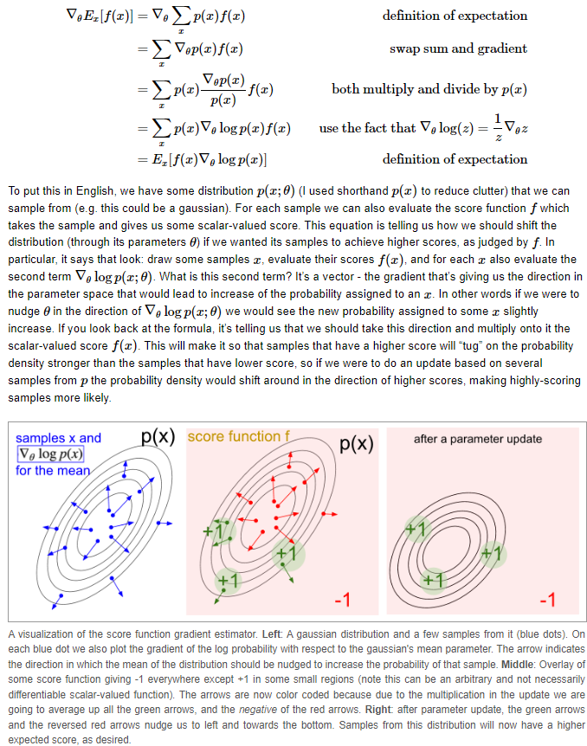adjustments maximize rewards. This mathematical foundation offers insight into how policy gradients are derived and utilized in reinforcement learning.

**Prompt:**

**Now I am pasting the next page. Get ready to explain how you have explained before. I had to repeatedly ask you to breakdown the concepts and AI terminologies used again and again, this time when you generate the explanation do it all for me as if I have zero knowledge about the AI terminologies. Wait for me to paste the content**

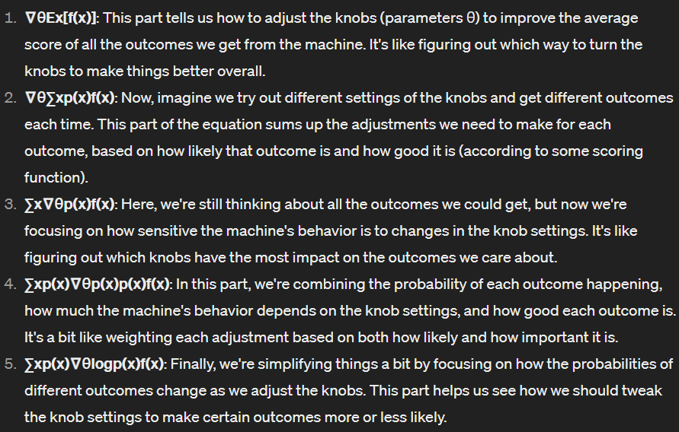Imagine we have a magical machine that can spit out different outcomes (let's call them samples) depending on how we set its knobs (parameters). We're interested in tweaking these knobs to get better outcomes, but we need some guidance on which direction to turn them. Here is the breakdown of the equation:

Putting it all together, this equation is like a recipe for figuring out how to adjust the knobs of our magical machine to get better outcomes overall. We're essentially looking for the best combination of knob settings that will make the machine produce more of the outcomes we like and fewer of the ones we don't.

**Intuition Behind Policy Gradients:** The concept of policy gradients revolves around learning to make decisions in an environment, such as playing a game like Pong. Instead of following a predetermined set of actions, the policy network learns by trial and error.

It samples actions stochastically, meaning it randomly selects actions based on their probabilities. Actions that lead to positive outcomes are reinforced, while those that lead to negative outcomes are discouraged. This reinforcement learning approach allows the network to gradually improve its decision-making over time.

**Training Protocol:** The training protocol involves iteratively playing the game and updating the policy network based on the outcomes. After playing a batch of games, the network evaluates each decision made during gameplay.

Actions taken in successful games are encouraged, while those in unsuccessful games are discouraged. By adjusting the network parameters in the direction that maximizes rewards, the policy network learns to make better decisions, ultimately improving its performance in the game.

**Advantage Functions and Generalization:** In addition to simply winning or losing a game, more complex reward structures can be used to evaluate decisions at each timestep. For example, a discounted reward mechanism considers not only immediate outcomes but also future rewards, weighted by a discount factor.

This allows the policy network to learn not just from immediate success or failure but also from the long-term consequences of its decisions. Additionally, techniques like standardizing returns help stabilize the training process by normalizing rewards, ensuring that updates to the network are consistent and effective across different games and scenarios.

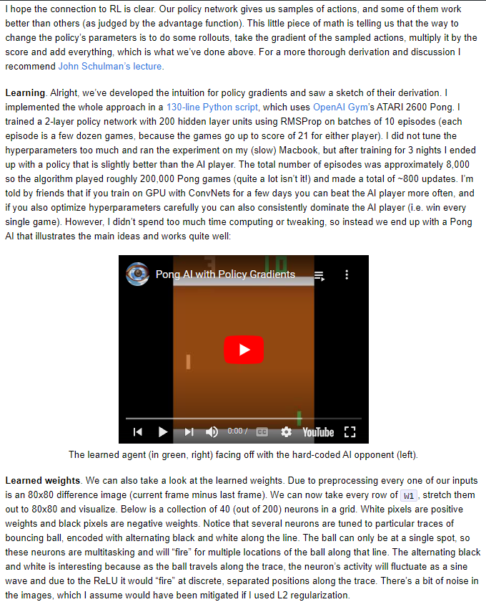**Prompt:**

**Now I am pasting the next page. Get ready to explain how you have explained before. I had to repeatedly ask you to breakdown the concepts and AI terminologies used again and again, this time when you generate the explanation do it all for me as if I have zero knowledge about the AI terminologies. Wait for me to paste the content**

**Policy Gradients and RL Connection:** In Reinforcement Learning (RL), our policy network suggests actions for us to take in a given situation, like playing Pong. Some actions turn out to be better than others, and we use a concept called "advantage function" to figure that out. This function helps us adjust our policy network by telling us which actions were more effective than others.

**Learning Process Overview:** Learning Process Overview: In our implementation, we're training a policy network to play the game of Pong using a Python script comprising approximately 230 lines of code. We utilize the Pong environment from the OpenAI Gym, specifically the ATARI 2600 version. Unlike the previous overview, our network architecture consists of two hidden layers, with the first layer containing 200 neurons and the second layer containing 100 neurons.

We employ the policy gradient method for training, which involves updating the network parameters based on the gradients of the expected rewards. This optimization is carried out using the Adam optimizer, which adapts the learning rate for each parameter individually based on the past gradients and squared gradients.

During training, the agent interacts with the environment by playing multiple episodes, with each episode comprising several games of Pong. The training process occurs in batches of 20 episodes, allowing the network to learn from a variety of experiences before updating its parameters.

One notable aspect of our implementation is the use of discounted rewards, where rewards obtained in future time steps are discounted to prioritize immediate rewards. This encourages the agent to focus on actions that lead to short-term gains while still considering long-term strategies.

Overall, our training process involves iteratively playing games of Pong, collecting experiences, computing gradients, and updating the network parameters to improve the agent's performance. Through this iterative process, the agent gradually learns to play Pong more effectively, ultimately aiming to achieve a high score and outperforming its opponents.

**Learning Results:** After training the network on my MacBook for three nights, the resulting policy was slightly better than the built-in AI player. We played around 200,000 games of Pong across approximately 8,000 episodes, making about 800 updates to the network during that time. After training the network on my windows Laptop for about 1,00,000 episodes

**Further Improvements:** While my setup was limited, friends have suggested that with more powerful hardware and careful tuning of hyperparameters, it's possible to consistently outperform the built-in AI player, winning every game.

**Examining Learned Weights:** We can peek into the "brain" of our network by looking at its learned weights. Since we've preprocessed our inputs to be 80x80 difference images, each row of the weight matrix represents a visual pattern.

Visualizing some of these neurons, we can see patterns emerge, like specific trajectories of the bouncing ball, encoded in the alternating black and white pixels.

**Interpreting Learned Weights:** The visual patterns in the learned weights represent what the network has learned to recognize in the game environment. For example, certain neurons might be sensitive to the movement of the ball or the position of the player's paddle. By examining these patterns, we gain insight into how the network makes decisions based on the game state.

**Noise in Learned Weights:** The presence of some noise in the learned weights suggests that our network might benefit from regularization techniques, like L2 regularization, which helps to reduce overfitting. This means that the network may be focusing on irrelevant details or memorizing specific examples instead of learning generalizable patterns. Applying regularization could lead to more robust and reliable performance.

Now let’s have a look at the code step by step. I will take you through each line of the code, and explain in great detail why it is needed, what role is the piece of code fulfilling and also attach resources if you would like to learn more about certain implementations or functionalities.

**First, we'll explore the Hyperparameters section, where we define crucial settings that influence the training process:**

# Import necessary libraries

import numpy as np  # For numerical operations

import pickle  # For saving and loading Python objects

import gym  # To interact with the gym environment (Pong game)

import matplotlib.pyplot as plt  # For plotting purposes

# Hyperparameters: These are the settings that can be tuned to optimize performance

H = 200  # Number of neurons in the first hidden layer of the neural network

H2 = 100  # Number of neurons in the second hidden layer of the neural network

batch_size = 20  # Number of episodes to play before updating the network weights

learning_rate = 1e-4  # Speed at which the network learns during training

gamma = 0.99  # Discount factor for future rewards, to prioritize immediate rewards over distant ones

learning_rate_decay = 0.99  # Factor by which the learning rate decreases over time

lr_decay_every = 1000  # Number of episodes after which to apply learning rate decay

resume = True  # Whether to resume training from a saved model

render = False  # Whether to display the game screen during training

epsilon = 1.0  # Initial exploration rate, determining the probability of taking a random action

epsilon_final = 0.01  # Final value of epsilon, after decay

epsilon_decay = 0.995  # Factor by which epsilon decreases over time, making the agent act more greedily

# Adam Optimizer parameters: These settings help adjust how the optimizer updates the network weights

beta1 = 0.9

beta2 = 0.999

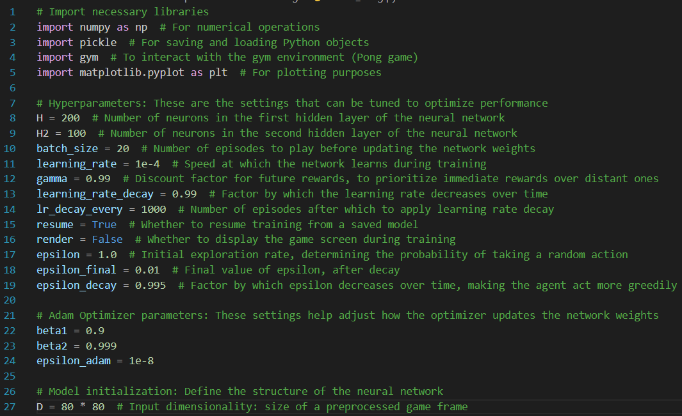epsilon_adam = 1e-8

# Model initialization: Define the structure of the neural network

D = 80 * 80  # Input dimensionality: size of a preprocessed game frame

1. **H**: Number of neurons in the first hidden layer of the neural network.
   * This parameter defines the size of the first hidden layer in the neural network used for training the Pong-playing agent. More neurons allow the network to capture more complex patterns in the input data but also increase computational complexity.
2. **H2**: Number of neurons in the second hidden layer of the neural network.
   * Similar to **H**, this parameter determines the size of the second hidden layer in the neural network. Having multiple hidden layers can help the network learn hierarchical representations of the input data.

In the context of neural networks, hierarchical representation refers to the idea that the layers of a network learn to extract increasingly abstract and complex features from the raw input data as information flows through the network. Each layer in the network captures different levels of abstraction, with lower layers learning simple patterns and higher layers learning more complex patterns by combining features learned from lower layers.

Here's a more detailed explanation:

**Simple to Complex Features:** At the lowest layers of a neural network, neurons typically learn to detect simple features or patterns in the input data. For example, in image recognition tasks, these features might include edges, corners, or color gradients.

**Building Blocks:** As we move up through the layers of the network, neurons combine these simple features to form more complex patterns or shapes. These higher-level features represent combinations of the lower-level features and are more abstract representations of the input data.

**Hierarchy:** The network's architecture, with multiple layers stacked on top of each other, allows for the creation of a hierarchical representation of the input data.

Each layer captures increasingly abstract and informative features, building upon the representations learned by the previous layers.

**Task-Specific Representation:** The hierarchical representation learned by the network is tailored to the specific task it's trained on. For example, in image classification tasks, the final layers of the network may learn to recognize specific objects or classes based on the combination of features learned in the lower layers.

**Improved Learning and Generalization:** Hierarchical representation enables the network to learn more efficiently and generalize better to unseen data.

By gradually building up complex representations from simpler ones, the network can capture the underlying structure of the data and make accurate predictions or classifications.

**So, are we fine tuning more and more as we add more layers and is it because more layers implies more fine tuning because of the ReLU function?**

Yes, adding more layers to a neural network allows for more fine-tuning and refinement of the learned representations, and the presence of activation functions like ReLU (Rectified Linear Unit) contributes to this process. Here's how:

* Increasing Capacity for Representation:
  + Adding more layers to a neural network increases its capacity to represent complex functions. Each layer in the network learns to extract increasingly abstract and informative features from the input data. This hierarchical representation allows the network to capture intricate patterns and relationships present in the data.
* Nonlinear Transformations with Activation Functions:
  + Activation functions like ReLU introduce nonlinearity into the network, enabling it to learn and represent nonlinear relationships in the data. The ReLU function allows the ****network to model complex, nonlinear mappings between the input and output, which is crucial for learning from real-world data that often exhibits nonlinear behavior.
* Fine-Tuning and Refinement:
  + As the network trains on the data, the parameters (weights and biases) of each layer are adjusted to minimize the difference between the predicted outputs and the true targets. With more layers, the network can fine-tune its internal representations to better capture the nuances and complexities present in the data.
  + The presence of ReLU activation functions allows for more precise adjustments in the network's representations. ReLU introduces sparsity and encourages the network to focus on the most relevant features while discarding irrelevant ones, leading to more efficient and effective learning.

ReLU (Rectified Linear Unit) activation function is applied to each layer of a neural network, especially in modern architectures like deep feedforward networks or convolutional neural networks. Here's why ReLU is commonly used and how it's applied:

* **Nonlinearity**:
  + ReLU introduces nonlinearity into the network, which is essential for learning complex mappings between the input and output. Without nonlinear activation functions like ReLU, the network would essentially be a linear model, incapable of capturing intricate patterns and relationships in the data.
* **Sparsity**:
  + ReLU provides sparsity in the network by setting negative values to zero. This sparsity encourages the network to focus on the most relevant features while disregarding less informative ones. By promoting sparsity, ReLU helps prevent the issues of vanishing gradients and accelerates convergence during training.

****Sparsity refers to the property of having a large number of zero or near-zero values in a dataset or representation. In the context of neural networks and machine learning, sparsity can have several implications and benefits:

Sparsity, induced by activation functions like ReLU (Rectified Linear Unit), can help mitigate the issue of vanishing gradients in deep neural networks. Here's how sparsity contributes to preventing vanishing gradients and accelerating convergence during training:

* **Encouraging Non-Saturation**:
  + ReLU activation function avoids saturation for positive inputs, meaning it does not exhibit diminishing gradients for positive values. This property prevents the gradients from vanishing as they propagate backward through the network, allowing them to maintain a reasonable magnitude throughout the layers.
* **Efficient Gradient Flow**:
  + In ReLU-activated layers, only a subset of neurons (those with positive activations) contribute to the forward pass. Neurons with negative activations are effectively inactive and do not contribute to the computation, leading to sparse activations.
  + This sparsity ensures that gradients are propagated only to active neurons during backpropagation, focusing the flow of gradients on relevant pathways. As a result, the gradients are less likely to become diluted or vanish as they propagate backward, leading to more efficient gradient flow through the network.
* **Preventing Saturation**:
  + ReLU prevents saturation by keeping negative inputs unchanged (i.e., setting them to zero). As a result, ReLU maintains a consistent gradient of ****1 for positive inputs, ensuring that gradients neither explode nor vanish as they propagate backward.
  + This non-saturating property of ReLU helps prevent the problem of vanishing gradients and allows gradients to flow freely through the network, facilitating faster convergence during training.
* **Accelerating Convergence**:
  + By promoting sparse activations and maintaining consistent gradients for positive inputs, ReLU accelerates convergence during training. The efficient flow of gradients through the network ensures that parameter updates are made effectively, leading to faster learning and convergence towards the optimal solution.

In summary, sparsity induced by ReLU activation function helps prevent vanishing gradients by maintaining consistent gradient flow through the network. By focusing the flow of gradients on active pathways and preventing saturation, ReLU accelerates convergence during training and enhances the ability of deep neural networks to effectively learn complex representations from data.

Certainly! Let's break it down into simpler terms:

The ReLU activation function is like a switch: if the input is positive, it keeps it as it is; if it's negative, it sets it to zero. This simple function helps the neural network learn better because:

* **Avoiding Diminishing Gradients**: Unlike some other activation functions, ReLU doesn't have a problem with tiny gradients when the input is positive. This means that as information goes back through the network during training, the gradients (which tell the network how much to adjust its parameters) don't become too small to be useful.
* **Keeping Gradients Reasonable**: By not letting the gradients get too small, ReLU helps to keep them at a reasonable size as they move through the layers of the network.

This ensures that each layer can learn from the mistakes of the previous layers without those mistakes becoming too insignificant to learn from.

So, in simpler terms, ReLU is like a helpful friend that makes sure the messages (gradients) that the network sends to each other during training are big enough to make a difference, which helps the network learn better and faster.

**How Does the size of the gradients get reduced as they propagate backwards?**

The size of gradients can get reduced as they propagate backward through deep neural networks due to a phenomenon called "vanishing gradients." Here's a simplified explanation:

* **Chain Rule of Derivatives**:
  + During the training of a neural network, gradients are computed using the chain rule of derivatives. Gradients are calculated recursively, starting from the output layer, and moving backward through the layers of the network.
  + Each layer computes its gradient with respect to its inputs based on the gradient received from the layer above it. This process continues until the gradients reach the input layer.
* **Saturation of Activation Functions**:
  + Activation functions like sigmoid and tanh have regions where their gradients become very small (approaching zero) for large positive ****or negative inputs. This means that as gradients propagate backward through many layers, they can encounter these regions of small gradients.
  + When gradients encounter saturated regions of activation functions, they get multiplied by small values, causing them to diminish exponentially as they move backward through the network.
* **Cumulative Effect**:
  + As gradients pass through multiple layers, the effects of small gradients get compounded. Each layer multiplies the incoming gradient by its own weight matrix, which can further reduce the magnitude of gradients.
  + With each layer, the gradients can become progressively smaller until they become too small to have a meaningful impact on the parameters of the earlier layers.
* **Deep Architectures**:
  + In deep neural networks with many layers, the problem of vanishing gradients becomes more pronounced. Gradients may vanish or become extremely small before they reach the early layers of the network.
  + This limits the ability of the network to effectively learn from distant or global features in the input data, hindering its performance on complex tasks.

In summary, the size of gradients can diminish as they propagate backward through deep neural networks due to the cumulative effect of small gradients encountered in each layer, especially in the presence of activation functions that saturate for large inputs. This phenomenon, known as vanishing gradients, 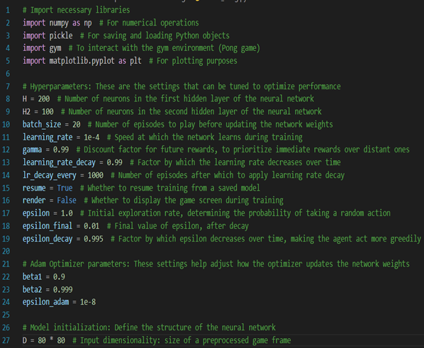can impede the training of deep architectures and limit their ability to learn complex representations from data.

**How does ReLU ensure the gradients don't get too small?**

ReLU (Rectified Linear Unit) ensures that gradients don't get too small in a simple way:

* **Non-Saturation for Positive Inputs**:
  + When the input to the ReLU activation function is positive, ReLU simply passes it through without any alteration. In other words, if the input is greater than zero, the gradient of ReLU remains constant and equal to 1.
  + Unlike activation functions like sigmoid or tanh, which can saturate for large positive inputs and cause gradients to become very small, ReLU keeps the gradient at a constant value of 1 for positive inputs.
* **Constant Positive Gradient**:
  + Because ReLU maintains a constant positive gradient for positive inputs, it ensures that gradients don't diminish as they propagate backward through the network.
  + During backpropagation, when gradients are calculated recursively using the chain rule of derivatives, ReLU's constant gradient ensures that the gradients remain reasonably large and do not vanish even as they pass through multiple layers.
* **Efficient Learning**:
  + By preserving the magnitude of gradients for positive inputs, ReLU promotes more efficient learning in deep neural networks. Gradients retain their usefulness as they propagate backward ****through the layers, allowing each layer to learn from the errors and adjust its parameters effectively.
  + This efficient propagation of gradients helps prevent the problem of vanishing gradients, enabling deeper networks to learn complex representations from data more effectively.

In summary, ReLU ensures that gradients don't get too small by maintaining a constant positive gradient for positive inputs. This property helps prevent the issue of vanishing gradients and facilitates more efficient learning in deep neural networks.

* **Efficiency**:
  + ReLU is computationally efficient to compute compared to other activation functions like sigmoid or tanh, as it involves simple thresholding operations (setting negative values to zero). This efficiency makes ReLU well-suited for training deep neural networks, where computational resources may be limited.
* **Avoiding Saturation**:
  + ReLU helps mitigate the problem of saturation that occurs with sigmoid and tanh activations, especially in deeper networks. Saturation refers to the phenomenon where gradients become very small, leading to slow learning or even vanishing gradients. ReLU's linear nature for positive inputs prevents saturation and facilitates better gradient flow during backpropagation.

Here's how ReLU is applied in each layer of a neural network:

* After performing the linear transformation (multiplication by weights and addition of bias) in each layer, the resulting activations are passed through the ReLU function elementwise.
* Mathematically, ReLU(x) = max(0, x), where x is the input to the activation function. It simply sets negative values to zero and leaves positive values unchanged.
* ****This process is repeated for each neuron in the layer, ensuring that the network benefits from the nonlinear activation properties of ReLU.

By applying ReLU activation to each layer, the neural network can effectively learn complex representations of the input data and achieve high performance on various tasks such as classification, regression, or reinforcement learning.

* Feature Hierarchy:
  + Each layer in a deep neural network learns to transform the input data into a higher-level representation. These representations become increasingly abstract and informative as we move deeper into the network. By stacking multiple layers with nonlinear activations like ReLU, the network can learn to extract hierarchical features that capture both low-level and high-level patterns in the data.

In summary, adding more layers to a neural network, along with using nonlinear activation functions like ReLU, allows for more fine-tuning and refinement of the learned representations. This enables the network to capture complex relationships in the data and ultimately improve its performance on various tasks such as classification, regression, or reinforcement learning.

1. **batch_size**: Number of episodes to play before updating the network weights.
   * updating the neural network weights based on the experiences collected. A larger batch size can provide more stable updates but may require more memory and computational resources.
2. **learning_rate**: Speed at which the network learns during training.
   * The learning rate determines the magnitude of updates applied to the network weights during training. A higher learning rate means larger updates, which can lead to faster convergence but may also result in overshooting optimal solutions or instability.
3. **gamma**: Discount factor for future rewards, to prioritize immediate rewards over distant ones.
   * ****Gamma (γ) controls the importance of future rewards in the agent's decision-making process. A higher gamma value means the agent considers future rewards more heavily, leading to more far-sighted behavior.
4. **learning_rate_decay**: Factor by which the learning rate decreases over time.
   * This parameter controls the rate at which the learning rate decays over the course of training. Decay helps fine-tune learning as the training progresses, allowing for more precise adjustments to the model parameters.
5. **lr_decay_every**: Number of episodes after which to apply learning rate decay.
   * Specifies how often (in terms of episodes) the learning rate decay should be applied. Decay at regular intervals can help the learning process by gradually reducing the learning rate as the training progresses.
6. **resume**: Whether to resume training from a saved model.
   * This boolean parameter determines whether the training should start from scratch or resume from a previously saved model. Resuming training allows for continuous training across multiple sessions without losing progress.
7. **render**: Whether to display the game screen during training.
   * Another boolean parameter that controls whether the game screen should be displayed while training the agent. Displaying the screen can be helpful for visualizing the agent's behavior but may also slow down training.
8. **epsilon**: Initial exploration rate, determining the probability of taking a random action.
   * Epsilon (ε) is used in an epsilon-greedy exploration strategy, where the agent randomly selects actions with probability ε and selects the action with the highest estimated reward with probability (1 - ε). This balance between exploration and exploitation helps the agent discover new strategies while gradually favoring more optimal actions.

****These hyperparameters play crucial roles in training the agent and can be fine-tuned to improve performance. Understanding their effects and adjusting them appropriately is essential for designing effective reinforcement learning algorithms.

As for resources to learn more about these concepts and the Python syntax used in the code, here are some useful links:

* For reinforcement learning concepts: [OpenAI Spinning Up](https://spinningup.openai.com/en/latest/)
* For Python syntax and programming concepts: [Python Documentation](https://docs.python.org/3/tutorial/index.html) and [W3Schools Python Tutorial](https://www.w3schools.com/python/default.asp)

**When is a gradient negative ?**

A gradient can be negative when the function being differentiated is decreasing at a particular point. Let's break it down:

1. **Gradient as a Derivative**:
   * In calculus, the gradient of a function represents the rate of change of that function at a specific point. It's essentially the slope of the tangent line to the function's curve at that point.
   * Mathematically, the gradient of a function 𝑓(𝑥) at a point 𝑥 is given by its derivative 𝑓′(𝑥). If the derivative is positive, it means the function is increasing at that point; if it's negative, the function is decreasing.
2. **Negative Gradient Interpretation**:
   * When the gradient (or derivative) of a function is negative at a point, it indicates that the function is decreasing at that point. In other words, as you move to the right from that point, the function values are decreasing.
   * Graphically, this corresponds to the function's curve sloping downward to the right of that point.
3. **Applications in Machine Learning**:
   * In the context of machine learning and neural networks, gradients are used to update the parameters of the model during training.

These gradients represent the direction and magnitude of the steepest ascent of the loss function with respect to the model parameters.

* + During optimization (e.g., gradient descent), if the gradient of the loss function with respect to a parameter is negative, it means that increasing the parameter value would decrease the loss.

Therefore, the parameter is adjusted in the opposite direction (i.e., decreased) to minimize the loss.

In summary, a gradient is negative when the function it represents is decreasing at a particular point. In machine learning, negative gradients indicate the direction in which model parameters should be adjusted to decrease the loss function and improve the model's performance.

**So gradient is like slope but also with direction like a vector?**

Exactly! The gradient is indeed similar to the slope of a function, but it includes both magnitude (how steep the slope is) and direction. In other words, it's like a vector that points in the direction of the steepest ascent of the function.

Here's a comparison to clarify:

1. **Slope**:
   * In basic calculus, slope refers to how steep a line is. It's a scalar value that tells you how much the dependent variable (y) changes for a given change in the independent variable (x).
   * Slope doesn't have direction; it's just a measure of steepness.
2. **Gradient**:
   * The gradient, on the other hand, is a vector that includes both magnitude and direction. It tells you not only how steep the function is but also the direction in which it's steepest.
   * In higher dimensions (such as in the case of multivariable functions), the gradient points in the direction of the steepest ascent of the function.

So, while slope gives you information about how steep a function is, the gradient provides additional information about the direction in which the function is changing most rapidly. In machine learning, we use gradients to guide the optimization process, adjusting model parameters in the direction that minimizes (or maximizes) a certain objective function, such as the loss function.

In basic calculus, when we compute the slope of a line between two points on a graph, the resulting value can indeed be negative if the line is sloping downwards from left to right.

However, while the negative slope indicates that the line is decreasing, it doesn't explicitly specify the direction in which this decrease occurs.

In basic calculus, the notion of slope is typically discussed in terms of positive or negative values, representing the upward or downward direction of the line, respectively.

However, the concept of directionality becomes more nuanced when we move into multivariable calculus and deal with functions of multiple variables.

When we talk about gradients in multivariable calculus, the negative values of the gradient components do represent a specific direction in the multidimensional space. Each component of the gradient vector indicates the rate of change of the function with respect to a particular variable, and the sign of each component indicates the direction in which the function is changing most rapidly.

Therefore, in the context of gradients, negative values do carry directional information, unlike in basic calculus where slope is primarily discussed in terms of positive or negative values without explicit directional connotations.

**Ok so setting the positive gradients implies the parameters we got the positive gradients for cause the increase in the loss function so we would like to update those parameters only. Is it so ?**

Exactly! When we encounter positive gradients during optimization, it indicates that increasing the corresponding parameters would lead to an increase in the loss function or objective being minimized. Since our goal is to minimize the loss function, we want to adjust those parameters in a way that decreases the loss.

Therefore, during optimization algorithms like gradient descent, we update the parameters in the direction opposite to the positive gradient. By moving the parameters in this direction, we aim to decrease the loss function and improve the model's performance.

Conversely, when we encounter negative gradients, it indicates that increasing the corresponding parameters would lead to a decrease in the loss function. In this case, we adjust those parameters in the direction of the negative gradient to move closer to the optimal solution.

By iteratively updating the parameters based on the gradients of the loss function, optimization algorithms guide the model towards minimizing the loss and improving its performance on the task at hand.

**So, all the negative gradients are moving the parameters in the direction of the negative gradient. Whereas for the positive ones we aim to move them opposite to the direction of the gradient to minimize the loss function?**

Exactly! Let's break it down:

1. **Negative Gradients**:
   * When encountering negative gradients during optimization, it indicates that increasing the corresponding parameters would lead to a decrease in the loss function.
   * ****To minimize the loss function, we adjust those parameters in the direction of the negative gradient. This means updating the parameters in the direction opposite to the negative gradient.
   * By moving the parameters in the direction of the negative gradient, we aim to decrease the loss function and improve the model's performance.
2. **Positive Gradients**:
   * Conversely, when encountering positive gradients, it indicates that increasing the corresponding parameters would lead to an increase in the loss function.
   * To minimize the loss function, we adjust those parameters in the direction opposite to the positive gradient. This means updating the parameters in the direction opposite to the positive gradient.
   * By moving the parameters in the direction opposite to the positive gradient, we aim to decrease the loss function and improve the model's performance.

In both cases, the goal is to iteratively update the parameters based on the gradients of the loss function, guiding the model towards minimizing the loss and improving its performance on the task at hand.

Mathematically, when we encounter positive gradients and aim to move the parameters in the opposite direction, we typically achieve this by subtracting a fraction of the gradient from the parameters. This is based on the principle of gradient descent optimization.

When we talk about "direction" in the context of gradient descent optimization, we're referring to the direction in which we update the parameters to minimize the loss function. This direction is determined by the sign of the gradient:

1. **Negative Gradient**:
   * If the gradient is negative, it indicates that the function is decreasing, and we move the parameters in the direction of the negative gradient to decrease the loss.
2. **Positive Gradient**:
   * If the gradient is positive, it indicates that the function is increasing, and we move the parameters in the direction opposite to the positive gradient to decrease the loss.

So, when we perform the calculation during gradient descent, we don't explicitly count it as negative or positive in terms of the parameter update. Instead, we use the sign of the gradient to determine the direction of the update. Mathematically, this is achieved by subtracting the gradient (scaled by the learning rate) from the parameters, which effectively adjusts the parameters in the direction opposite to the positive gradient or in the direction of the negative gradient.

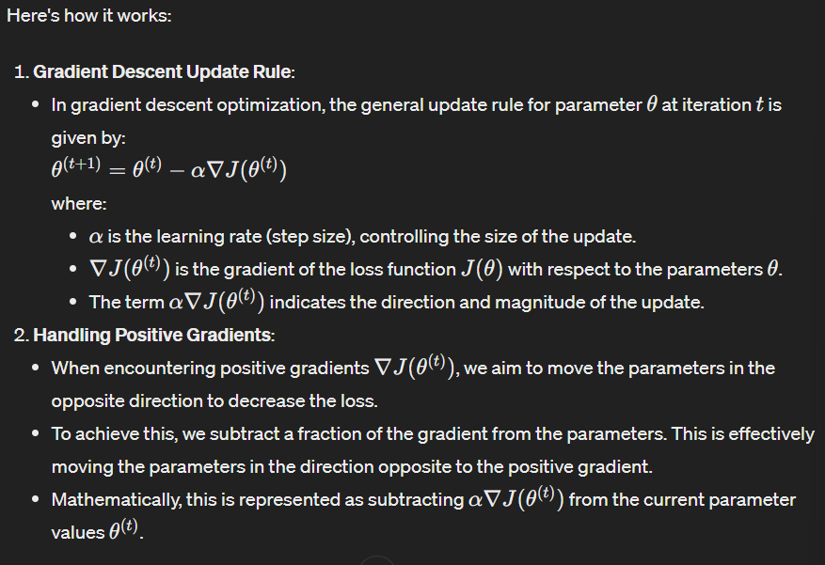In essence, we're performing vector operations to update the parameters in the direction that minimizes the loss function, guided by the sign of the gradient.

Let's go through each hyperparameter and provide a description of how to approach tuning or modifying it:

1. **H (Number of neurons in the first hidden layer)**:
   * Purpose: This hyperparameter determines the number of neurons (units) in the first hidden layer of the neural network.
   * Approach: The choice of the number of neurons in a hidden layer can impact the capacity and expressiveness of the neural network. Increasing the number of neurons can allow the network to learn more complex patterns but may also increase the risk of overfitting. Readers can experiment with different values of 𝐻*H* to find a balance between model complexity and generalization performance.
2. **H2 (Number of neurons in the second hidden layer)**:
   * Purpose: Similar to 𝐻*H*, this hyperparameter determines the number of neurons in the second hidden layer of the neural network.
   * Approach: Adding additional hidden layers or neurons can increase the model's capacity to capture complex relationships in the data. However, it also introduces more parameters, increasing the risk of overfitting. Readers can adjust 𝐻2*H*2 along with 𝐻*H* to explore different architectures and find the optimal balance between model complexity and generalization.
3. **batch_size (Number of episodes to play before updating the network weights)**:
   * Purpose: This hyperparameter determines the number of episodes (games) the agent plays before updating the neural network weights.
   * Approach: The choice of batch size can affect the stability and efficiency of training. Larger batch sizes may lead to more stable updates but require more memory and computational resources. Smaller batch sizes can lead to faster updates but may introduce more variability in the training process. Readers can experiment with different batch sizes to find the optimal trade-off between stability and efficiency.
4. **learning_rate (Speed at which the network learns during training)**:
   * Purpose: This hyperparameter controls the step size of parameter updates during training.
   * Approach: The learning rate determines how quickly or slowly the model parameters are adjusted based on the gradient of the loss function. Choosing an appropriate learning rate is crucial for successful training. Too high of a learning rate may lead to unstable training or divergence, while too low of a learning rate may result in slow convergence. Readers can perform grid or random search over a range of learning rates to find the optimal value.
5. **gamma (Discount factor for future rewards)**:
   * Purpose: This hyperparameter determines the weight given to future rewards in the reinforcement learning setting.
   * Approach: Gamma affects the agent's preference for immediate rewards versus long-term rewards. A higher gamma value prioritizes long-term rewards, while a lower value focuses more on immediate rewards. Readers can adjust gamma based on the specific characteristics of the environment and the desired behavior of the agent.
6. **learning_rate_decay (Factor by which the learning rate decreases over time)**:
   * Purpose: This hyperparameter controls the rate at which the learning rate decays during training.
   * Approach: Learning rate decay can be useful for fine-tuning the training process. Decaying the learning rate over time can help the model converge more smoothly towards an optimal solution and avoid overshooting. Readers can experiment with different decay schedules and rates to find the optimal learning rate decay strategy.
7. **lr_decay_every (Number of episodes after which to apply learning rate decay)**:
   * Purpose: This hyperparameter determines the frequency at which the learning rate is decayed during training.
   * ****Approach: By decaying the learning rate at regular intervals, the training process can adapt to changing dynamics in the environment and stabilize learning. Readers can adjust the value of 𝑙𝑟_𝑑𝑒𝑐𝑎𝑦_𝑒𝑣𝑒𝑟𝑦*lr*_*decay*_*every* based on the pace of learning and the complexity of the task.
8. **resume (Whether to resume training from a saved model)**:
   * Purpose: This hyperparameter specifies whether training should resume from a previously saved model checkpoint.
   * Approach: Setting 𝑟𝑒𝑠𝑢𝑚𝑒*resume* to true allows the training process to continue from where it left off, which can be useful for long training sessions or if training is interrupted. Readers can toggle this parameter based on their training workflow and whether they want to continue from a saved checkpoint.
9. **render (Whether to display the game screen during training)**:
   * Purpose: This hyperparameter determines whether the game screen is rendered (displayed) during training.
   * Approach: Rendering the game screen can provide visual feedback on the agent's behavior and progress during training. However, it also incurs additional computational overhead. Readers can choose to render the game screen based on their preference for visual feedback and the computational resources available.
10. **epsilon (Initial exploration rate, determining the probability of taking a random action)**:
    * Purpose: This hyperparameter controls the exploration-exploitation trade-off in reinforcement learning.
    * Approach: Epsilon-greedy exploration balances between exploring new actions and exploiting the current best action. Higher values of epsilon encourage more exploration, while lower values prioritize exploitation of known actions. Readers can adjust epsilon based on the agent's learning progress and the desired level of exploration.
11. **epsilon_final (Final value of epsilon, after decay)**:
    * Purpose: This hyperparameter specifies the final value of epsilon after decay.
    * Approach: Decaying epsilon over time allows the agent to gradually shift from exploration to exploitation as training progresses. Setting epsilon_final to a small value ensures that the agent eventually focuses primarily on exploiting the learned policy. Readers can adjust epsilon_final based on the desired exploration-exploitation strategy and convergence behavior.
12. **epsilon_decay (Factor by which epsilon decreases over time, making the agent act more greedily)**:
    * Purpose: This hyperparameter controls the rate at which epsilon decreases over time.
    * Approach: Epsilon decay schedules influence the balance between exploration and exploitation during training. Slower decay rates prolong exploration, while faster decay rates promote earlier exploitation. Readers can experiment with different decay rates to find the optimal exploration-exploitation strategy for their task.
13. **beta1, beta2 (Adam Optimizer parameters)**:
    * Purpose: These hyperparameters control the exponential decay rates for the first and second moments of the gradient in the Adam optimizer.
    * Approach: Beta1 and beta2 determine the influence of past gradients on the current parameter update. Higher values of beta1 and beta2 give more weight to recent gradients, while lower values give more weight to historical gradients. Readers can adjust beta1 and beta2 based on the characteristics of the optimization landscape and the desired behavior of the optimizer.
14. **epsilon_adam (Adam Optimizer parameter)**:
    * Purpose: This hyperparameter is a small constant added to the denominator for numerical stability in the Adam optimizer.
    * Approach: Epsilon_adam prevents division by zero and stabilizes the optimizer's calculations. It is typically set to a small value to avoid numerical issues during optimization. Readers usually do not need to modify this parameter unless encountering numerical instability during training.

When tuning or modifying hyperparameters, it's essential to consider their interplay and the potential trade-offs between them. Conducting systematic experiments, such as grid search or random search, can help identify the best hyperparameter configuration for a given task and environment.

Additionally, monitoring training progress and performance metrics can provide valuable insights into the impact of hyperparameter choices on the model's behavior and learning dynamics.

# Activation and utility functions

def sigmoid(x):

    """ Compute the sigmoid function, used for calculating probabilities """

    return 1.0 / (1.0 + np.exp(-x))

def leaky_relu(x, alpha=0.01):

    """ Compute the leaky ReLU activation, allowing for a small gradient when the unit is not active """

    return np.where(x > 0, x, x * alpha)

def prepro(I):

    """ Preprocess game frames for input into the network: crop, downsample, erase background, and binarize """

    I = I[35:195]  # Crop to play area

    I = I[::2, ::2, 0]  # Downsample by factor of 2 and take the red channel (simplification)

    I[I == 144] = 0  # Erase background type 1

    I[I == 109] = 0  # Erase background type 2

    I[I != 0] = 1  # Set everything else (paddles, ball) to 1

    return I.astype(np.float64).ravel()  # Flatten into vector

def discount_rewards(r):

    """ Compute discounted rewards over an episode: rewards that come later are worth less than immediate rewards """

    discounted_r = np.zeros_like(r)

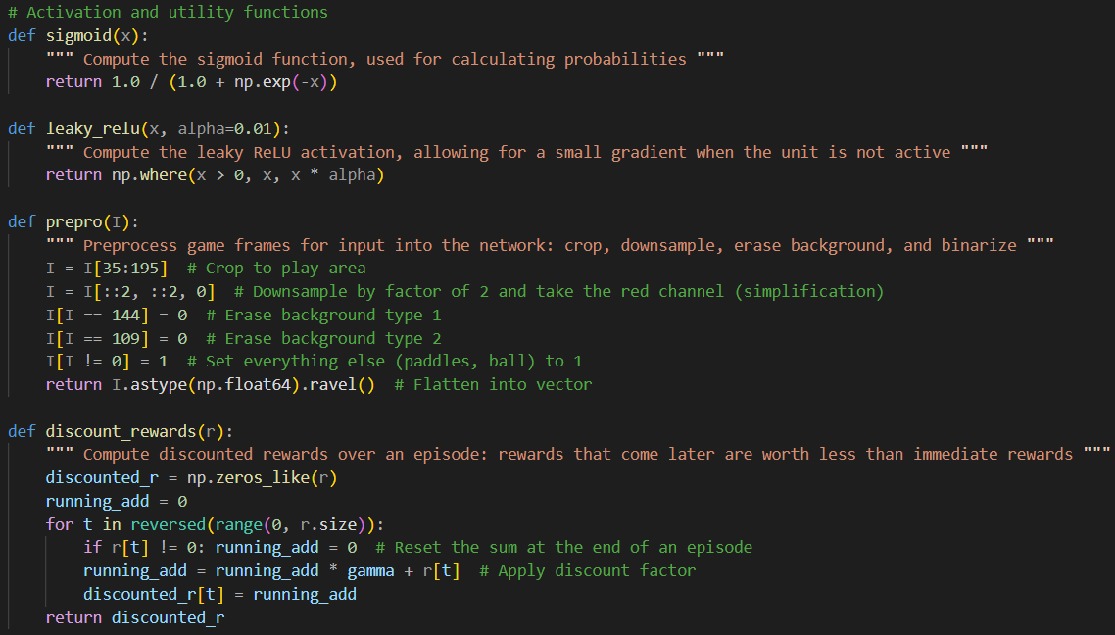    running_add = 0

    for t in reversed(range(0, r.size)):

        if r[t] != 0: running_add = 0  # Reset the sum at the end of an episode

        running_add = running_add * gamma + r[t]  # Apply discount factor

        discounted_r[t] = running_add

    return discounted_r

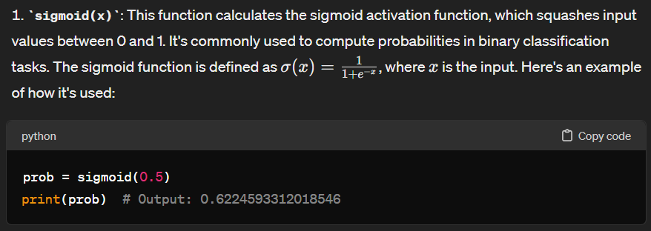

The **sigmoid** function is an activation function that's commonly used in neural networks, especially in the output layer of binary classification tasks. Its primary purpose is to squash the input values to a range between 0 and 1, effectively interpreting them as probabilities. In our reinforcement learning scenario, the **sigmoid** function is crucial for determining the probability of taking a specific action, particularly in binary decisions such as moving up or down in the Pong game.

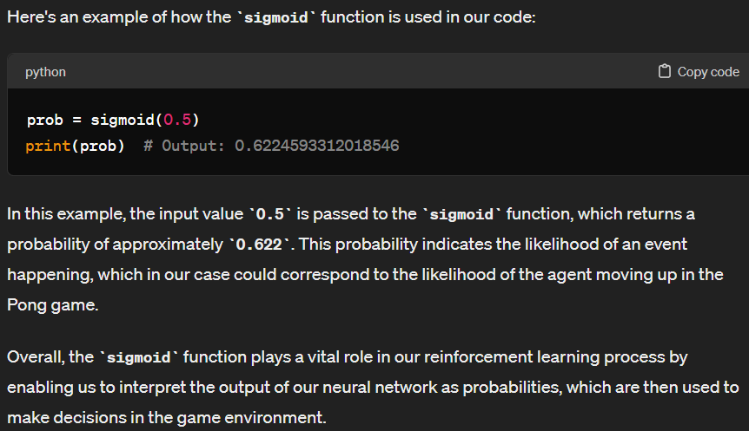Here's a breakdown of why we use the **sigmoid** function and where it fits into our reinforcement learning process:

1. **Probability Calculation**: In reinforcement learning, we often need to decide between two actions based on their probabilities. For example, in the game of Pong, the agent needs to decide whether to move the paddle up or down. The **sigmoid** function allows us to convert the output of our neural network into probabilities, where values closer to 1 indicate a higher probability of taking one action (e.g., moving up) and values closer to 0 indicate a higher probability of taking the other action (e.g., moving down).
2. **Action Selection**: After applying the **sigmoid** function to the output of our neural network, we can use these probabilities to decide which action the agent should take. We often sample from these probabilities to select actions stochastically, taking into account the uncertainty in our predictions.

The input 𝑥 to the sigmoid function can vary. It can be any real number, positive, negative, or zero. The sigmoid function will map this input value to a value between 0 and 1, which represents the probability of a certain event happening.

For example, if 𝑥 is a large positive number, the sigmoid function will output a value close to 1, indicating a high probability of the event occurring. Conversely, if 𝑥 is a large negative number, the sigmoid function will output a value close to 0, indicating a low probability of the event occurring. event happening or not happening.

So, while the input 𝑥 can technically be greater than 1 or less than 0, the sigmoid function will always map it to a value between 0 and 1.

The probability calculated by the sigmoid function is typically computed for every iteration or timestep in the reinforcement learning process. In the context of our code, the probability is computed whenever the agent needs to make a decision or take an action based on the current state of the environment.

During each iteration of the training process, the agent interacts with the environment, observes the current state, and calculates the probability of taking each possible action. This probability calculation is essential for determining the action selection strategy of the agent, particularly in policy-based reinforcement learning algorithms like the one implemented in our code.

So, in most reinforcement learning algorithms, including the one in our code, the probability is computed at each iteration or timestep to inform the agent's decision-making process.

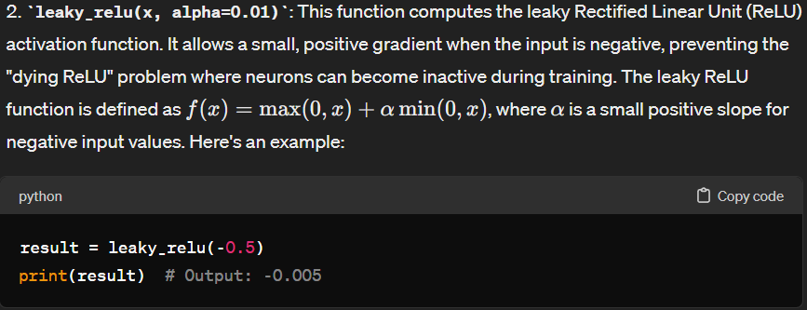

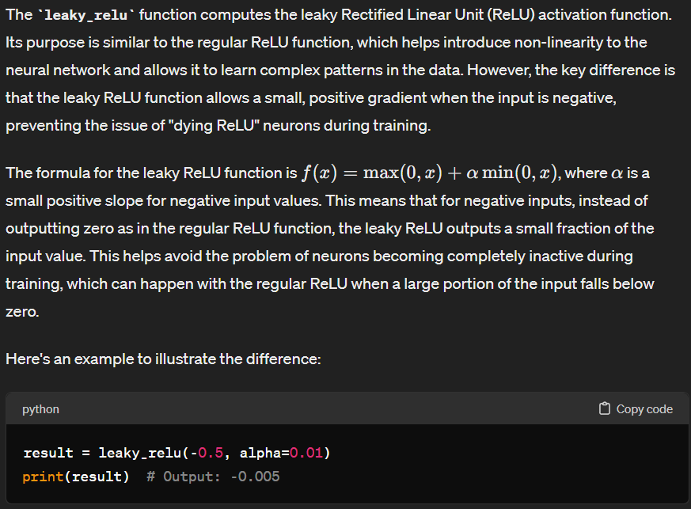

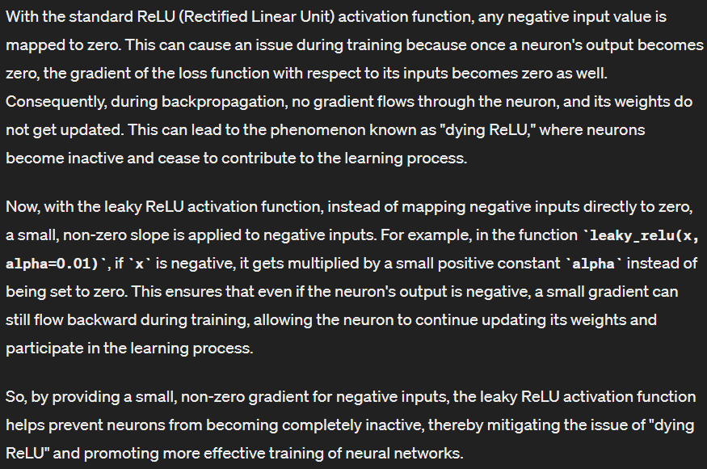

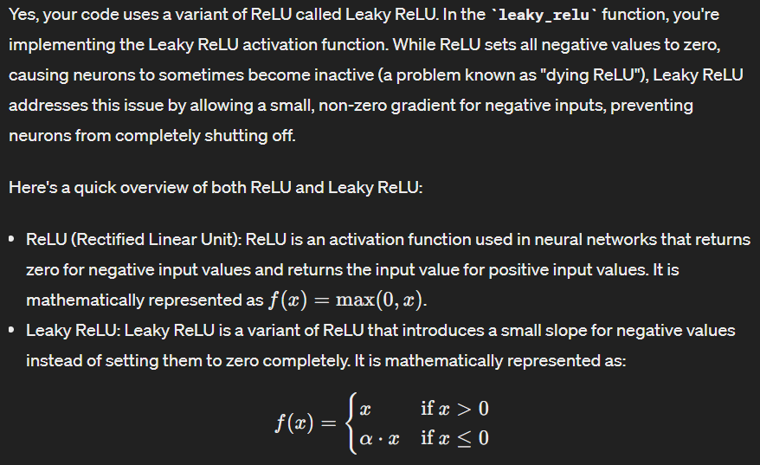

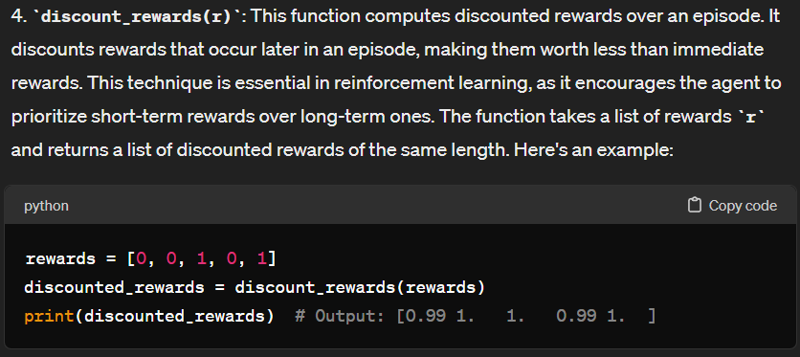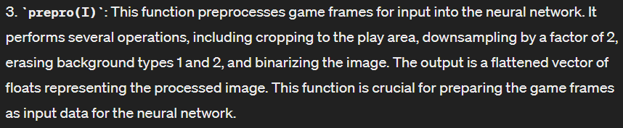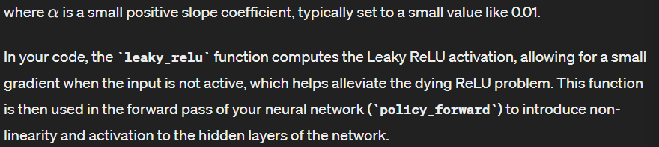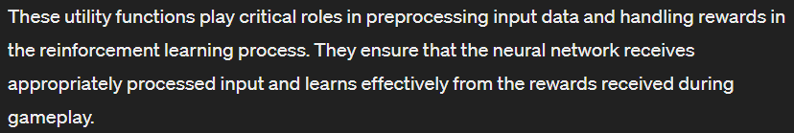

**Purpose:**

The **discount_rewards** function computes discounted rewards over an episode in reinforcement learning. It's crucial because it addresses the problem of assigning credit to actions that lead to future rewards, especially in tasks where rewards are delayed.

**How it Works:**

1. **Initialization**:
   * **discounted_r**: An array to store the discounted rewards.
   * **running_add**: A variable to keep track of the cumulative sum of rewards.
2. **Looping Backwards Through the Episode**:
   * We start from the last time step and move backward to the first. This is because in many reinforcement learning problems, rewards occur later in time are more uncertain and less relevant to past actions.
3. **Discounting and Accumulating Rewards**:
   * For each time step **t**, if the reward at that step (**r[t]**) is non-zero, it indicates the end of an episode, so **running_add** is reset to zero.
   * Then, we apply a discount factor (**gamma**) to the running sum of rewards (**running_add**) and add the current reward (**r[t]**) to it. This discounted sum represents the total expected future reward from the current time step onward.
   * The discounted sum is stored in **discounted_r** at the corresponding time step **t**.
4. **Returning Discounted Rewards**:
   * After looping through all time steps, the function returns the array **discounted_r**, containing the discounted rewards for each time step.

**Example:**

Let's consider a simple scenario with rewards **[1, 1, 0, 1, 0]** and **gamma = 0.9**:

* At time step 4, the immediate reward is 1. Then, the discounted reward would be **1 * gamma + 0 = 0.9**.
* At time step 3, the immediate reward is 0. Then, the discounted reward would be **0 * gamma + 0.9 = 0.9**.
* At time step 2, the immediate reward is 1. Then, the discounted reward would be **1 * gamma + 0 = 0.9**.
* At time steps 1 and 0, the immediate rewards are both 1. The discounted rewards would be **1 * gamma + 1 = 1.9**.

So, the function would return **[1.9, 0.9, 0.9, 0.9, 0.0]**, reflecting the decreasing influence of future rewards as we move backward in time.

**Sources for Further Learning:**

* Reinforcement Learning: An Introduction by Richard S. Sutton and Andrew G. Barto (Chapter 3).
* David Silver's Reinforcement Learning Course on YouTube.
* OpenAI Spinning Up in Deep RL: <https://spinningup.openai.com/en/latest/algorithms/vpg.html#computing-advantages-and-discounted-rewards>.

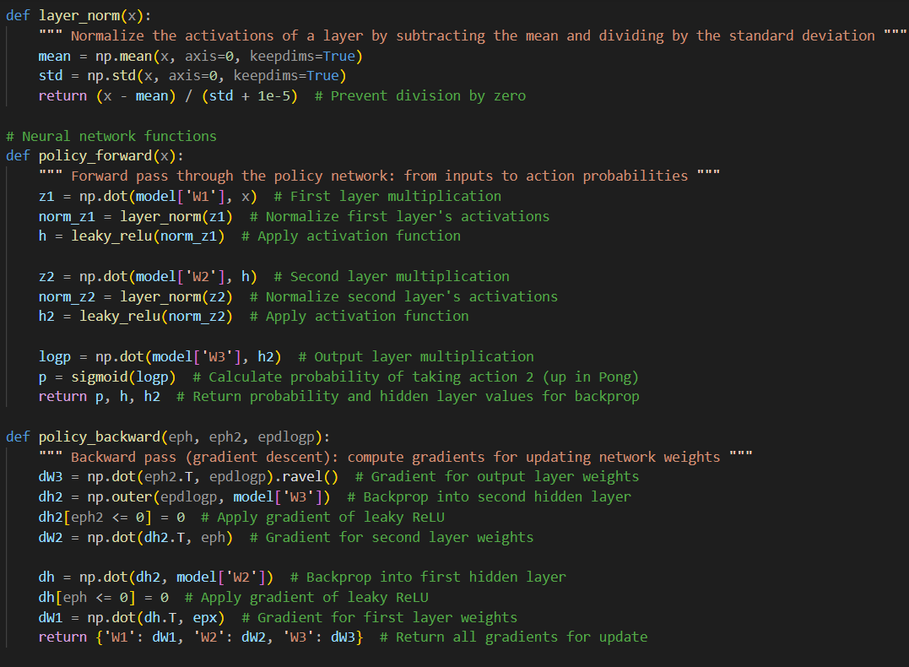

def layer_norm(x):

    """ Normalize the activations of a layer by subtracting the mean and dividing by the standard deviation """

    mean = np.mean(x, axis=0, keepdims=True)

    std = np.std(x, axis=0, keepdims=True)

    return (x - mean) / (std + 1e-5)  # Prevent division by zero

# Neural network functions

def policy_forward(x):

    """ Forward pass through the policy network: from inputs to action probabilities """

    z1 = np.dot(model['W1'], x)  # First layer multiplication

    norm_z1 = layer_norm(z1)  # Normalize first layer's activations

    h = leaky_relu(norm_z1)  # Apply activation function

    z2 = np.dot(model['W2'], h)  # Second layer multiplication

    norm_z2 = layer_norm(z2)  # Normalize second layer's activations

    h2 = leaky_relu(norm_z2)  # Apply activation function

    logp = np.dot(model['W3'], h2)  # Output layer multiplication

    p = sigmoid(logp)  # Calculate probability of taking action 2 (up in Pong)

    return p, h, h2  # Return probability and hidden layer values for backprop

def policy_backward(eph, eph2, epdlogp):

    """ Backward pass (gradient descent): compute gradients for updating network weights """

    dW3 = np.dot(eph2.T, epdlogp).ravel()  # Gradient for output layer weights

    dh2 = np.outer(epdlogp, model['W3'])  # Backprop into second hidden layer

    dh2[eph2 <= 0] = 0  # Apply gradient of leaky ReLU

    dW2 = np.dot(dh2.T, eph)  # Gradient for second layer weights

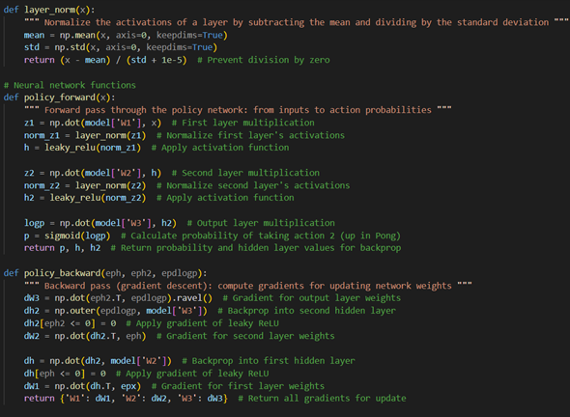    dh = np.dot(dh2, model['W2'])  # Backprop into first hidden layer

    dh[eph <= 0] = 0  # Apply gradient of leaky ReLU

    dW1 = np.dot(dh.T, epx)  # Gradient for first layer weights

    return {'W1': dW1, 'W2': dW2, 'W3': dW3}  # Return all gradients for update

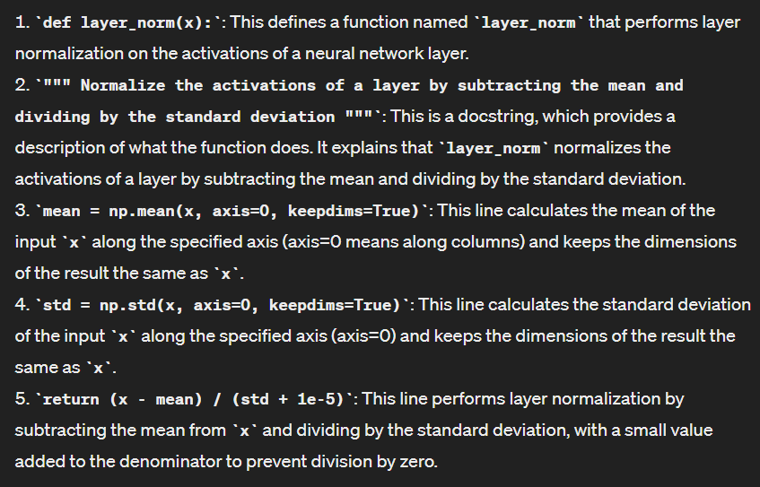

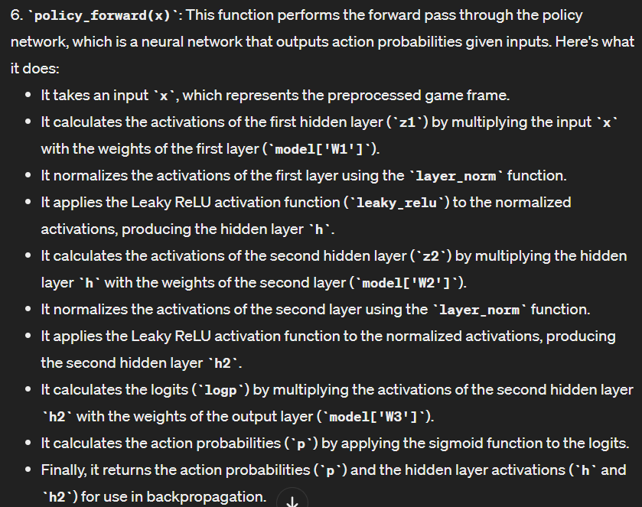

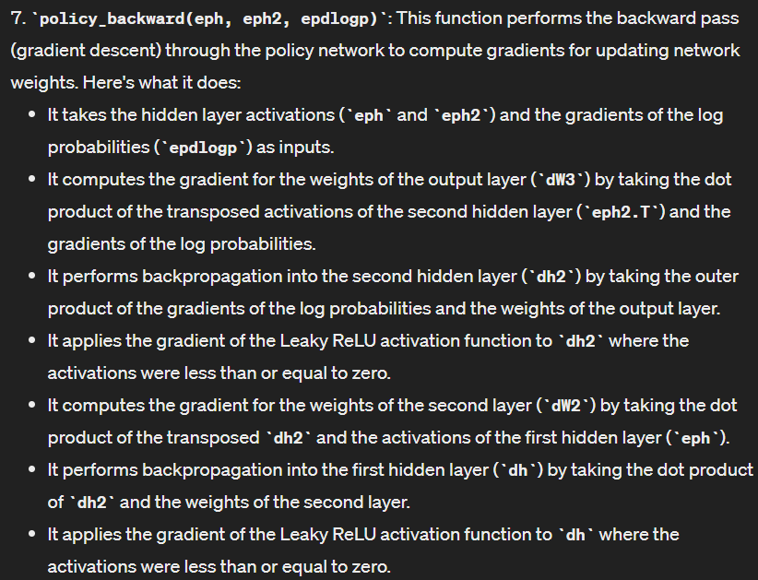

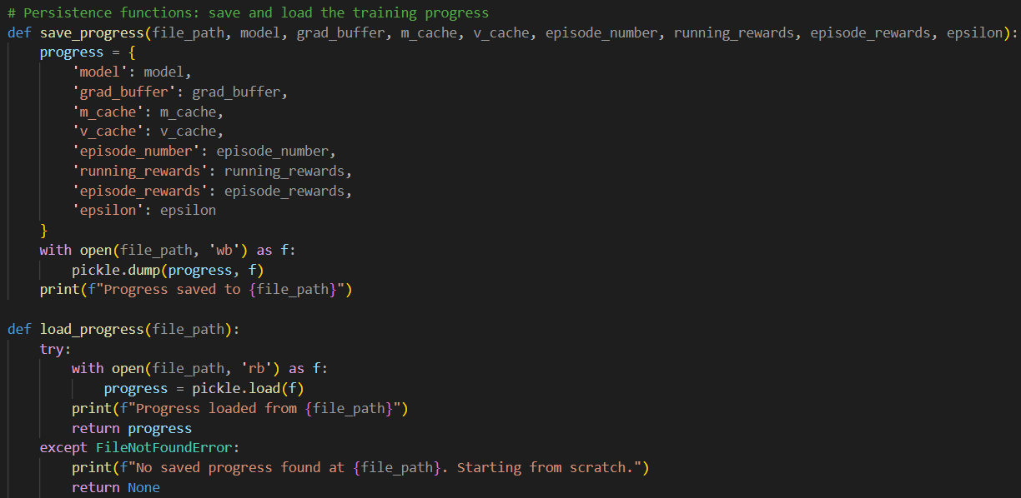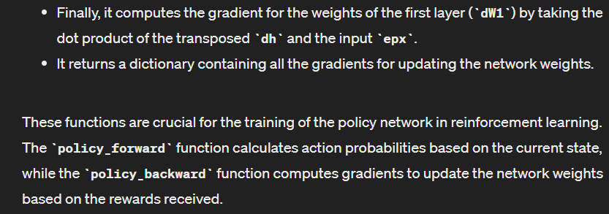

# Persistence functions: save and load the training progress

def save_progress(file_path, model, grad_buffer, m_cache, v_cache, episode_number, running_rewards, episode_rewards, epsilon):

    progress = {

        'model': model,

        'grad_buffer': grad_buffer,

        'm_cache': m_cache,

        'v_cache': v_cache,

        'episode_number': episode_number,

        'running_rewards': running_rewards,

        'episode_rewards': episode_rewards,

        'epsilon': epsilon

    }

    with open(file_path, 'wb') as f:

        pickle.dump(progress, f)

    print(f"Progress saved to {file_path}")

def load_progress(file_path):

    try:

        with open(file_path, 'rb') as f:

            progress = pickle.load(f)

        print(f"Progress loaded from {file_path}")

        return progress

    except FileNotFoundError:

        print(f"No saved progress found at {file_path}. Starting from scratch.")

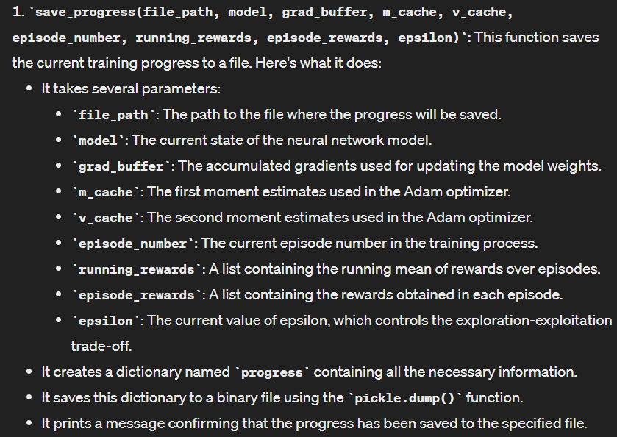        return None

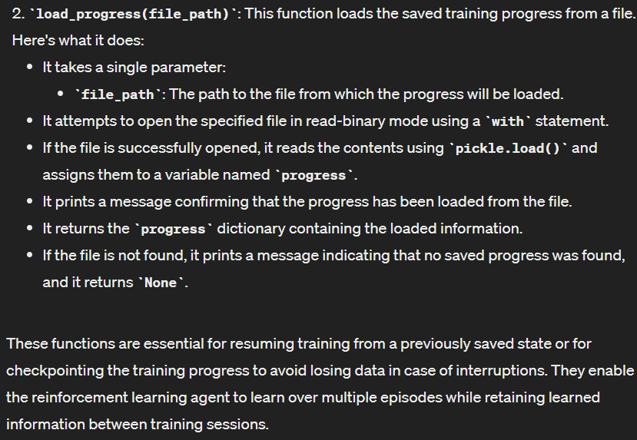

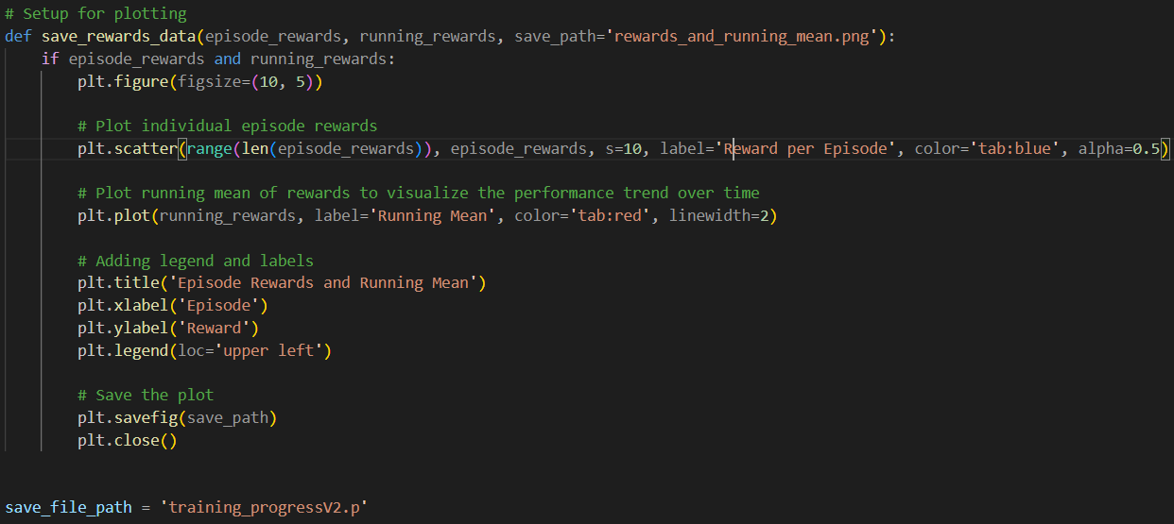

# Setup for plotting

def save_rewards_data(episode_rewards, running_rewards, save_path='rewards_and_running_mean.png'):

    if episode_rewards and running_rewards:

        plt.figure(figsize=(10, 5))

        # Plot individual episode rewards

        plt.scatter(range(len(episode_rewards)), episode_rewards, s=10, label='Reward per Episode', color='tab:blue', alpha=0.5)

        # Plot running mean of rewards to visualize the performance trend over time

        plt.plot(running_rewards, label='Running Mean', color='tab:red', linewidth=2)

        # Adding legend and labels

        plt.title('Episode Rewards and Running Mean')

        plt.xlabel('Episode')

        plt.ylabel('Reward')

        plt.legend(loc='upper left')

        # Save the plot

        plt.savefig(save_path)

        plt.close()

save_file_path = 'training_progressV2.p'

This function is responsible for plotting and saving the rewards data, including individual episode rewards and the running mean of rewards over time. Let's understand each part of the function:

1. **save_rewards_data(episode_rewards, running_rewards, save_path='rewards_and_running_mean.png')**: This function takes three parameters:
   * **episode_rewards**: A list containing the rewards obtained in each episode.
   * **running_rewards**: A list containing the running mean of rewards over episodes.
   * **save_path**: The file path where the plot will be saved. By default, it is set to 'rewards_and_running_mean.png'.
2. Inside the function:
   * It first checks if both **episode_rewards** and **running_rewards** lists are not empty. This ensures that there is data to plot.
   * It creates a new figure for the plot with a size of 10x5 inches using **plt.figure(figsize=(10, 5))**.
   * It plots the individual episode rewards as scatter points using **plt.scatter()**, with episode numbers on the x-axis and rewards on the y-axis. These points are labeled as 'Reward per Episode' and are colored blue with an alpha (transparency) value of 0.5 for better visualization.
   * It plots the running mean of rewards as a line plot using **plt.plot()**, using the **running_rewards** list. This line is labeled as 'Running Mean' and is colored red with a thicker linewidth for emphasis.
   * It adds a title to the plot using **plt.title()** and labels for the x-axis and y-axis using **plt.xlabel()** and **plt.ylabel()**, respectively.
   * It adds a legend to the plot indicating the meaning of each line using **plt.legend()**.
   * Finally, it saves the plot to the specified file path using **plt.savefig()** and closes the figure using **plt.close()**.

This function is useful for visualizing the training progress of the reinforcement learning agent, showing how the rewards change over episodes and how the running mean of rewards evolves over time. This visualization helps in understanding the learning dynamics and assessing the performance of the agent during training.

This function, **save_rewards_data()**, is essential for visualizing the performance of our reinforcement learning agent as it learns to play the Pong game. Let's break down the function into simpler parts:

1. **Plotting Episode Rewards and Running Mean**:
   * The function plots two important metrics: individual episode rewards and the running mean of rewards over time. These metrics help us understand how well our agent is performing and whether its performance is improving over the course of training.
2. **Creating the Plot**:
   * The function first creates a new plot with a size of 10x5 inches. Think of this as creating a blank canvas where we'll draw our rewards data.
3. **Plotting Individual Episode Rewards**:
   * Each point on the plot represents the reward obtained in a single episode of the game. These points are scattered along the x-axis, with the episode number increasing from left to right, and along the y-axis, representing the reward value.
   * These points are colored blue and have a slight transparency (alpha value of 0.5) to make them easier to see without obscuring other data points.
4. **Plotting the Running Mean of Rewards**:
   * The running mean gives us an idea of the average reward our agent is receiving over a certain number of episodes. It smooths out the fluctuations in individual episode rewards and helps us see the overall trend.
   * This is represented by a line plot, where the x-axis still represents the episode number, but the y-axis now shows the average reward over a sliding window of episodes.
   * This line is drawn in red and is thicker to make it stand out from the individual episode rewards.
5. **Adding Labels and Legend**:
   * The plot is given a title ('Episode Rewards and Running Mean') to indicate what it represents.
   * The x-axis is labeled 'Episode', and the y-axis is labeled 'Reward' to provide context for the data.
   * A legend is added to the plot to explain the meaning of each element: 'Reward per Episode' for the scattered points and 'Running Mean' for the line plot.
6. **Saving the Plot**:
   * Once the plot is complete, it is saved to a file specified by **save_path**. By default, it saves as 'rewards_and_running_mean.png'.
   * This allows us to view the plot later or share it with others to analyze the training progress.
7. **Closing the Plot**:
   * Finally, the function closes the plot to free up memory and resources. This step is important to prevent the accumulation of unused plots if the function is called multiple times.

By visualizing the rewards data using this function, we gain valuable insights into how our agent is learning and whether any adjustments are needed to improve its performance. This visualization is crucial for monitoring the training progress and making informed decisions throughout the training process.

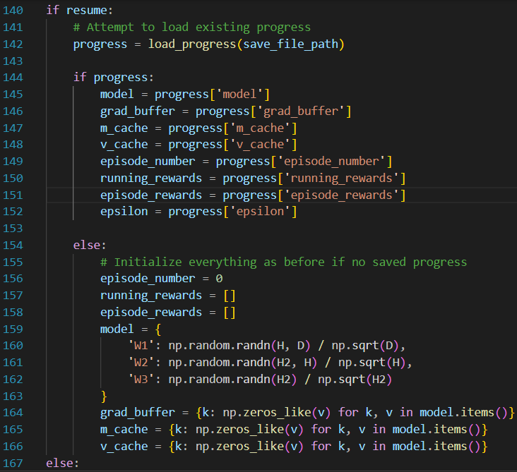

if resume:

    # Attempt to load existing progress

    progress = load_progress(save_file_path)

    if progress:

        model = progress['model']

        grad_buffer = progress['grad_buffer']

        m_cache = progress['m_cache']

        v_cache = progress['v_cache']

        episode_number = progress['episode_number']

        running_rewards = progress['running_rewards']

        episode_rewards = progress['episode_rewards']

        epsilon = progress['epsilon']

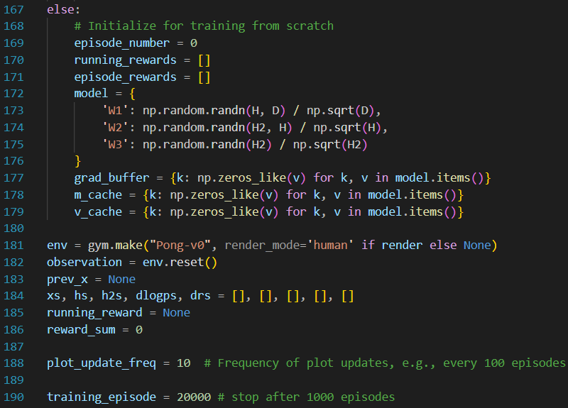    else:

        # Initialize everything as before if no saved progress

        episode_number = 0

        running_rewards = []

        episode_rewards = []

        model = {

            'W1': np.random.randn(H, D) / np.sqrt(D),

            'W2': np.random.randn(H2, H) / np.sqrt(H),

            'W3': np.random.randn(H2) / np.sqrt(H2)

        }

        grad_buffer = {k: np.zeros_like(v) for k, v in model.items()}

        m_cache = {k: np.zeros_like(v) for k, v in model.items()}

        v_cache = {k: np.zeros_like(v) for k, v in model.items()}

else:

    # Initialize for training from scratch

    episode_number = 0

    running_rewards = []

    episode_rewards = []

    model = {

        'W1': np.random.randn(H, D) / np.sqrt(D),

        'W2': np.random.randn(H2, H) / np.sqrt(H),

        'W3': np.random.randn(H2) / np.sqrt(H2)

    }

    grad_buffer = {k: np.zeros_like(v) for k, v in model.items()}

    m_cache = {k: np.zeros_like(v) for k, v in model.items()}

    v_cache = {k: np.zeros_like(v) for k, v in model.items()}

env = gym.make("Pong-v0", render_mode='human' if render else None)

observation = env.reset()

prev_x = None

xs, hs, h2s, dlogps, drs = [], [], [], [], []

running_reward = None

reward_sum = 0



plot_update_freq = 10  # Frequency of plot updates, e.g., every 100 episodes

training_episode = 20000 # stop after 1000 episodes

This block of code initializes or resumes the training process for our reinforcement learning agent. Let's go through it step by step:

1. **Resuming or Initializing Progress**:
   * If **resume** is **True**, it means we want to continue training from a saved checkpoint.
     + We attempt to load the saved progress using the **load_progress()** function, passing the file path **save_file_path**.
     + If progress is successfully loaded (**if progress:**), we retrieve the necessary variables such as the model weights, gradient buffers, caches, episode number, rewards, and epsilon (exploration rate). These variables allow us to continue training from where we left off.
     + If no progress is loaded, it means there's no saved checkpoint, so we initialize everything as if starting from scratch. We set **episode_number** to 0 and create empty lists for **running_rewards** and **episode_rewards**. We also initialize the model weights (**'W1'**, **'W2'**, **'W3'**), gradient buffers, and caches for optimization purposes.
   * If **resume** is **False**, it means we want to start training from the beginning. In this case, we follow the same steps as if no progress was loaded, initializing all necessary variables and structures.
2. **Environment Setup**:
   * We create the Pong environment using OpenAI's Gym library with the **gym.make()** function. Depending on the **render** flag, the environment might render the game screen ('human') or run in headless mode (None).
   * We reset the environment and obtain the initial observation (**observation = env.reset()**). This observation represents the first frame of the game.
3. **Initialization of Variables**:
   * **prev_x** is set to **None**. It will be used to store the previous preprocessed frame of the game.
   * Empty lists (**xs**, **hs**, **h2s**, **dlogps**, **drs**) are created to store information about each step in the episode.
   * **running_reward** is initialized to **None**. It will be used to track the running average of rewards over episodes.
   * **reward_sum** is initialized to 0. It will accumulate the rewards obtained in each episode.
4. **Training Configuration**:
   * **plot_update_freq** determines how often we'll update the plot showing the rewards data. For example, if set to 10, we update the plot every 10 episodes.
   * **training_episode** specifies the maximum number of episodes for training. Once this limit is reached, the training process will stop.

This block of code sets up the initial conditions for our training loop, ensuring that we can either start from scratch or continue training from a saved checkpoint. It also prepares the environment and initializes variables needed for training and monitoring the agent's progress.

Top of Form

while episode_number <= training_episode:

    cur_x = prepro(observation)

    x = cur_x - prev_x if prev_x is not None else np.zeros(D)

    prev_x = cur_x

    h, h2 = np.zeros((H,)), np.zeros((H2,))

    # Initialize aprob to a default value

    aprob = 0.5  # Default probability when action is chosen randomly

    if np.random.uniform() < epsilon:

        action = env.action_space.sample()

    else:

        aprob, h, h2 = policy_forward(x)

        action = 2 if np.random.uniform() < aprob else 3

    # Record the intermediates needed for backprop

    xs.append(x)

    hs.append(h)

    h2s.append(h2)

    y = 1 if action == 2 else 0

    dlogps.append(y - aprob)

    observation, reward, done, _ = env.step(action)

    reward_sum += reward

    drs.append(reward)

    if done:

        episode_number += 1

        epx = np.vstack(xs)

        eph = np.vstack(hs)

        eph2 = np.vstack(h2s)

        epdlogp = np.vstack(dlogps)

        epr = np.vstack(drs)

        xs, hs, h2s, dlogps, drs = [], [], [], [], []

        discounted_epr = discount_rewards(epr)

        discounted_epr -= np.mean(discounted_epr)

        discounted_epr /= np.std(discounted_epr)

        epdlogp *= discounted_epr

        grad = policy_backward(eph, eph2, epdlogp)

        for k in model: grad_buffer[k] += grad[k]

        if episode_number % batch_size == 0:

            for k, v in model.items():

                g = grad_buffer[k]

                m = beta1 * m_cache[k] + (1 - beta1) * g  # Update biased first moment estimate

                v = beta2 * v_cache[k] + (1 - beta2) * (g ** 2)  # Update biased second raw moment estimate

                m_hat = m / (1 - beta1 ** episode_number)  # Compute bias-corrected first moment estimate

                v_hat = v / (1 - beta2 ** episode_number)  # Compute bias-corrected second raw moment estimate

                model[k] += learning_rate * m_hat / (np.sqrt(v_hat) + epsilon_adam)  # Update parameters

                grad_buffer[k] = np.zeros_like(v)  # Reset gradients

                m_cache[k], v_cache[k] = m, v  # Update Adam caches

        if episode_number % lr_decay_every == 0:

            learning_rate *= learning_rate_decay

        epsilon = max(epsilon_final, epsilon * epsilon_decay)

        # boring book-keeping

        running_reward = reward_sum if running_reward is None else running_reward * 0.99 + reward_sum * 0.01

        print(f'resetting env. episode {episode_number} reward total was {reward_sum}. running mean: {running_reward}')

        episode_rewards.append(reward_sum)

        running_rewards.append(running_reward)

        reward_sum = 0

        observation = env.reset() # reset env

        prev_x = None

        if episode_number % 100 == 0:

            save_progress(save_file_path, model, grad_buffer, m_cache, v_cache, episode_number, running_rewards, episode_rewards, epsilon)

        if episode_number % plot_update_freq == 0 and episode_number != 0:

            save_rewards_data(episode_rewards, running_rewards)

    #if reward != 0:  # Pong has either +1 or -1 reward exactly when game ends.

        #print(f'ep {episode_number}: game finished, reward: {reward}' + (' !!!!!!!!' if reward == 1 else ''))

This block of code represents the training loop where the agent interacts with the environment and learns to play Pong. Let's break down each part:

1. **Loop Condition**:
   * The **while** loop continues until the **episode_number** exceeds the **training_episode** limit.
2. **Observation Preprocessing**:
   * **cur_x = prepro(observation)**: Preprocesses the current observation frame (**observation**) using the **prepro** function. This function crops, downsamples, erases background, and binarizes the frame to prepare it for input into the neural network.
   * **x = cur_x - prev_x if prev_x is not None else np.zeros(D)**: Computes the difference between the current preprocessed frame and the previous one (**prev_x**). If there is no previous frame (initial step), it creates a zero array of dimension **D**.
3. **Neural Network Forward Pass**:
   * **aprob, h, h2 = policy_forward(x)**: Performs a forward pass through the policy network (**policy_forward** function) to obtain the action probabilities (**aprob**) and hidden layer activations (**h**, **h2**) based on the input frame (**x**).
4. **Action Selection**:
   * The agent selects an action based on the action probabilities (**aprob**) and the exploration rate (**epsilon**).
     + If a randomly generated number is less than **epsilon**, the agent chooses a random action (exploration).
     + Otherwise, it chooses an action based on the probabilities predicted by the policy network.
5. **Recording Intermediates**:
   * Intermediate values needed for backpropagation are recorded:
     + **xs**, **hs**, **h2s**: Store input frames and hidden layer activations.
     + **dlogps**: Stores the difference between the chosen action probability and the actual action taken.
     + **drs**: Stores the rewards obtained at each step.
6. **Environment Interaction**:
   * **observation, reward, done, _ = env.step(action)**: Executes the chosen action in the environment and receives the next observation (**observation**), reward (**reward**), and termination signal (**done**).
7. **Episode Completion**:
   * If the episode is complete (**done** is **True**), the following steps are performed:
     + Compute the discounted rewards (**discounted_epr**) using the rewards obtained in the episode (**drs**).
     + Update the running reward and print episode statistics.
     + Store the episode rewards and running reward.
     + Reset the environment and intermediate lists.
     + Perform gradient ascent to update the neural network weights (**model**) using the obtained gradients (**grad**) and the Adam optimizer.
     + Adjust the learning rate (**learning_rate**) and exploration rate (**epsilon**) if necessary.
     + Save the training progress and update the rewards plot.
8. **Book-keeping**:
   * Book-keeping tasks include printing episode statistics, saving progress, and updating the rewards plot at regular intervals.

This loop repeats until the training episode limit is reached, allowing the agent to learn to play Pong by interacting with the environment, receiving rewards, and updating its policy based on the observed outcomes.

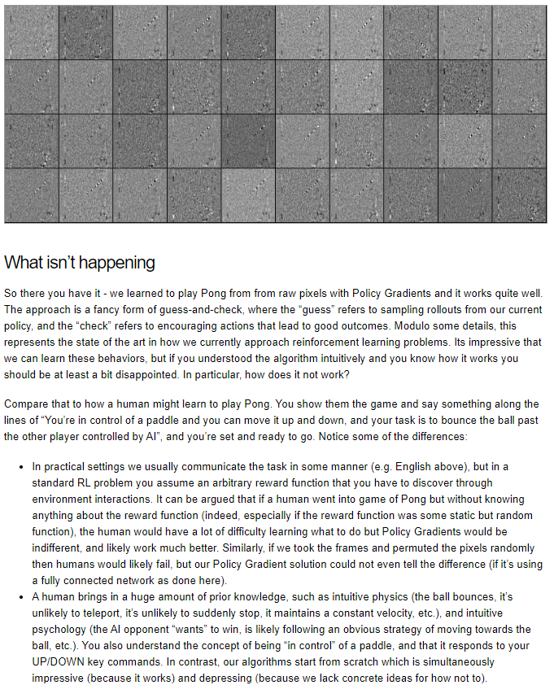The Policy Gradients approach to learning Pong from raw pixels is undoubtedly impressive, but it's important to recognize its limitations and areas where it falls short compared to human learning:

**Communication of Task:** Humans typically learn tasks through explicit communication or instruction. For example, someone might explain the objective of Pong and how to control the paddle. In contrast, reinforcement learning (RL) algorithms often operate in environments where the reward function, which defines what constitutes a good outcome, is not explicitly provided.

Instead, the algorithm must discover this reward function through trial-and-error interactions with the environment. This lack of initial guidance can make learning more challenging for humans compared to RL algorithms.

**Prior Knowledge:** Humans bring a wealth of prior knowledge and intuition to learning tasks like Pong. This includes an understanding of basic physics principles (such as the behavior of moving objects like the ball) and psychology (such as predicting the actions of opponents).

Additionally, humans have a conceptual understanding of control and how their actions affect the environment. In contrast, RL algorithms typically start with no prior knowledge and must learn from scratch, which can lead to slower learning and less efficient performance, especially in complex environments.

**Robustness to Perturbations:** Human learning is often robust to changes in the environment or task conditions. For example, humans can adapt to variations in visual input or unexpected changes in the game environment.

In contrast, RL algorithms like Policy Gradients may struggle to generalize to such changes, especially if they rely solely on raw pixel inputs without additional pre-processing or feature engineering.

Overall, while Policy Gradients and similar RL approaches have demonstrated remarkable capabilities in learning complex tasks from raw sensory inputs, they still lack the robustness, flexibility, and efficiency of human learning.

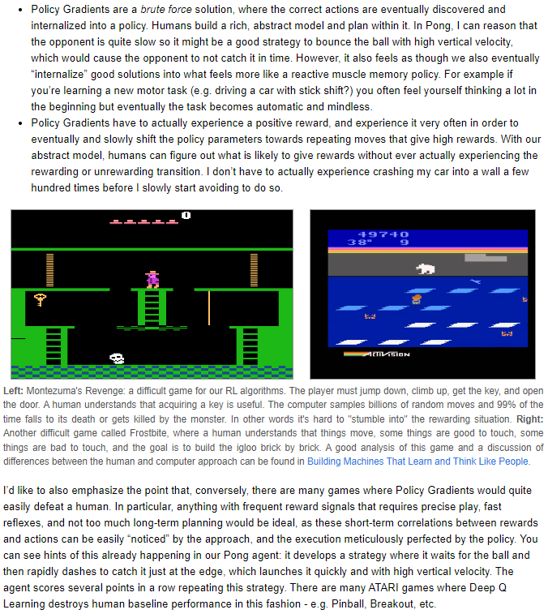Addressing these challenges remains an active area of research in the field of artificial intelligence.

Policy Gradients: This is a method used in reinforcement learning, where an AI learns by trying different actions and gradually adjusting its decision-making process based on the outcomes.

Unlike humans, who can plan ahead and build abstract models, AI trained with Policy Gradients relies on experiencing positive rewards frequently to improve its performance.

Brute force approach: Refers to the method of trying all possible options systematically until the correct solution is found. In the context of Policy Gradients, it means that the AI explores different actions through trial and error rather than relying on a predefined strategy.

Internalizing successful actions: This means that the AI incorporates successful actions into its decision-making process, making it more likely to repeat those actions in similar situations in the future. Essentially, the AI learns from its past experiences and adjusts its behavior accordingly.

Sparse rewards: In games like Montezuma's Revenge or Frostbite, rewards are infrequent or difficult to obtain, making it challenging for the AI to learn successful strategies. Sparse rewards pose a challenge for Policy Gradients because the AI needs frequent positive feedback to learn effectively.

Short-term correlations: Refers to the AI's ability to recognize patterns between its actions and immediate rewards. In games with frequent rewards and straightforward cause-and-effect relationships, Policy Gradients can quickly learn and optimize its behavior based on these short-term correlations.

In summary, while Policy Gradients offer a powerful learning method, their effectiveness depends on the complexity of the task and the availability of frequent rewards. They may struggle in games requiring long-term planning or complex reasoning but excel in games where quick reflexes and precise execution are key.

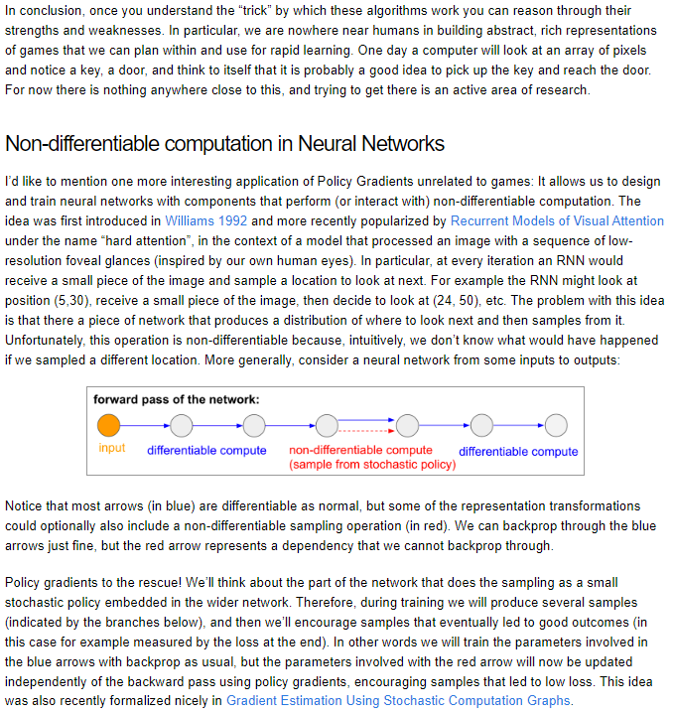Policy Gradients offer a fascinating window into how machines learn from experience, especially in environments where traditional rule-based programming falls short. Imagine teaching a computer to play a game like Pong without providing explicit rules.

Instead, the computer learns by trial and error, gradually discovering which actions lead to favorable outcomes. This process mirrors how humans learn new skills: through repeated attempts and adjustments based on feedback.

To understand the strengths and limitations of Policy Gradients, let's consider their application in gaming. While these algorithms excel in tasks with clear reward signals and short-term correlations, they struggle in more complex environments like Montezuma's Revenge or Frostbite.

In these games, understanding the significance of certain actions, like acquiring a key or avoiding obstacles, requires a level of abstract thinking that current AI approaches lack. However, Policy Gradients still shine in games where precise actions and quick reflexes are crucial, such as Pinball or Breakout.

Beyond gaming, Policy Gradients offer a clever workaround for training neural networks with non-differentiable components. For example, imagine a network designed to sequentially process different parts of an image, mimicking human visual attention. This process involves non-differentiable sampling operations, which pose challenges for traditional training methods. Here's where Policy Gradients come to the rescue: by treating the sampling process as a stochastic policy within the network, we can train these parameters independently, encouraging samples that lead to favorable outcomes.

In essence, Policy Gradients provide a powerful tool for training AI agents in complex environments, but they also highlight the gap between current AI capabilities and human-level understanding. While machines can learn from experience and improve over time, they still lack the intuition and 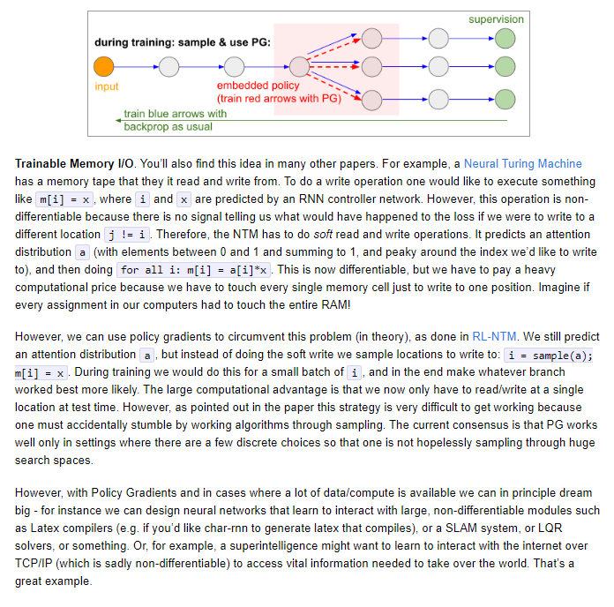abstraction that humans possess.

Nonetheless, ongoing research in this field continues to push the boundaries of what AI can achieve, offering exciting possibilities for the future of machine learning and artificial intelligence.

Top of Form

The idea of trainable memory input/output (I/O) is commonly found in various research papers, such as the Neural Turing Machine (NTM). In these models, there is a memory component that the system can read from and write to.

However, performing a write operation like m[i] = x, where i is the location and x is the value, is challenging because it's non-differentiable.

This means there's no signal indicating how the loss would change if we wrote to a different location. To address this, approaches like the NTM use soft read and write operations. Instead of directly writing to a specific location, they predict an attention distribution (a) that assigns weights to different memory locations, and then perform a weighted write operation for all locations. While this approach is differentiable, it's computationally expensive because it requires accessing all memory cells for each write operation.

Policy gradients offer a potential solution to this problem, as demonstrated in the RL-NTM approach. Instead of directly predicting attention weights, the model samples locations to write to based on the predicted distribution.

During training, multiple locations are sampled, and the branch that leads to the best outcome is reinforced. This approach offers a significant computational advantage, as it only requires writing to a single location at test time.

However, implementing this strategy is challenging because it relies on randomly sampling effective algorithms. Policy gradients are most effective in scenarios with a few discrete choices, where exhaustive search is feasible.

Despite the challenges, policy gradients present exciting possibilities in scenarios with abundant data and computational resources. For instance, neural networks could learn to interact with complex, non-differentiable systems like Latex compilers, SLAM (Simultaneous Localization and Mapping) 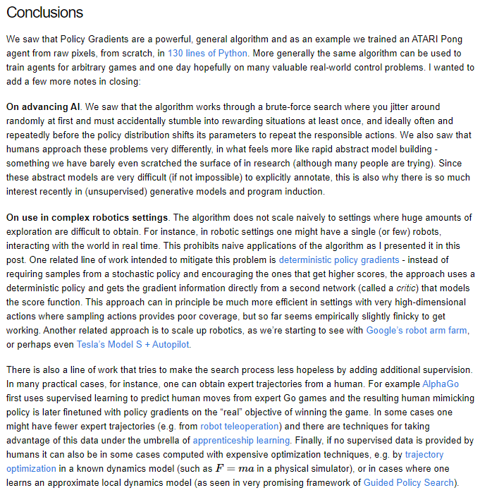systems, or LQR (Linear Quadratic Regulator) solvers.

Additionally, in hypothetical scenarios involving superintelligent systems, policy gradients could enable learning to interact with non-differentiable protocols like TCP/IP to access crucial information. While these examples are ambitious, they showcase the potential of policy gradients in tackling complex, real-world problems.

Policy Gradients offer a versatile and potent algorithmic framework, as demonstrated by training an ATARI Pong agent from raw pixels using just 130 lines of Python.

Beyond gaming, this algorithm holds promise for training agents in various games and real-world control problems. However, it's important to acknowledge its limitations and ongoing research efforts to address them.

The algorithm operates through a brute-force search strategy, where initial exploration involves random actions until rewarding situations are stumbled upon.

In contrast, humans approach problem-solving with rapid abstract model-building, a process that remains a significant challenge in AI research. The difficulty in explicitly annotating abstract models has sparked interest in unsupervised generative models and program induction techniques.

In complex robotics settings where extensive exploration is impractical, naive application of Policy Gradients faces challenges. Approaches like deterministic policy gradients and apprenticeship learning aim to mitigate these limitations by incorporating additional supervision or leveraging expert trajectories.

Furthermore, advancements in robotics infrastructure, such as Google's robot arm farm and Tesla's Model S with Autopilot, contribute to scaling up robotics applications and enhancing the efficacy of AI algorithms in real-world scenarios.

Using Policy Gradients (PG) in practice requires a realistic understanding of its strengths and limitations. While PG offers a powerful algorithmic framework, it's not a magic bullet. Implementing PG involves challenges such as requiring a large number of samples, lengthy training times, and 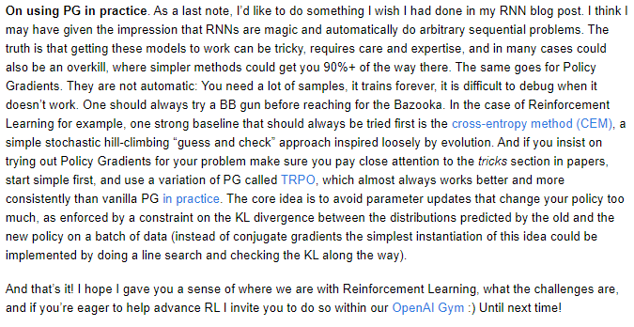difficulty in debugging when issues arise. Therefore, it's essential to approach problem-solving with PG methodically and consider simpler alternatives first.

One such alternative is the cross-entropy method (CEM), a straightforward stochastic hill-climbing approach inspired by evolution. Before diving into PG, it's advisable to experiment with CEM as a strong baseline. If PG is still preferred, it's crucial to pay attention to the various tricks and techniques outlined in research papers. Additionally, using a variation of PG called Trust Region Policy Optimization (TRPO) often yields more consistent results in practice. TRPO focuses on avoiding large policy updates by constraining the KL divergence between the distributions predicted by the old and new policies.

In conclusion, while PG offers exciting possibilities for advancing reinforcement learning, it's important to approach its implementation with caution and a solid understanding of its nuances. By experimenting systematically, leveraging alternative methods, and incorporating best practices like TRPO, researchers and practitioners can contribute to the ongoing development of RL algorithms within frameworks like OpenAI Gym.

Top of Form

Top of Form

Top of Form